Matlab/Simulink Bioprocess simulation

**Question 1**

There were three differentials $\frac{dX}{dt}= r_{X}$, $\frac{dS}{dt}= r_{s}$, and $\frac{dP}{dt}= r_{p}$

Below is the integrator block for $\frac{dS}{dt}= r_{s}$ initial condition is substrate concentration, S0 = 10 kg/m3

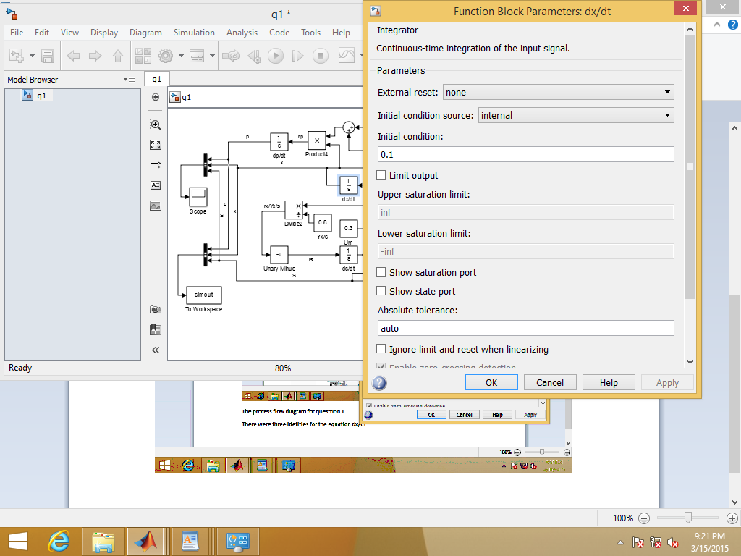

Integrator block for $\frac{dP}{dt}= r_{p}$ initial condition is product concentration, P0 = 0 kg/m3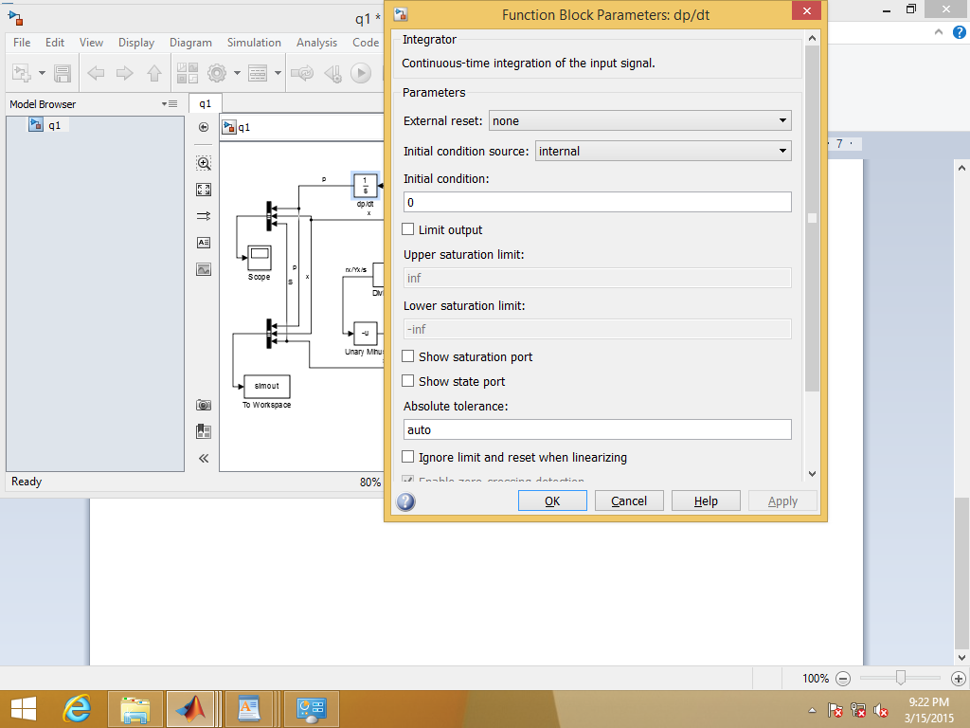

Integrator block for $\frac{dX}{dt}= r_{X}$ initial condition is inoculum concentration, X0 = 0.1 kg/m3

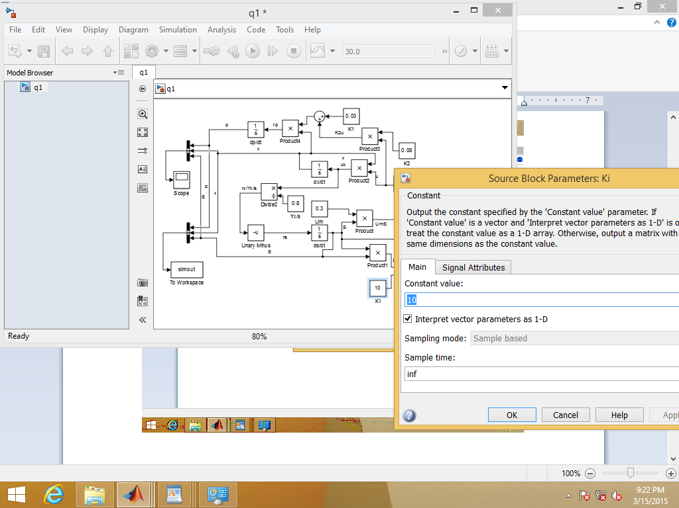

Constants blocks were created to represent the constants represented in the question. These were

Ks = 0.1 kg/m3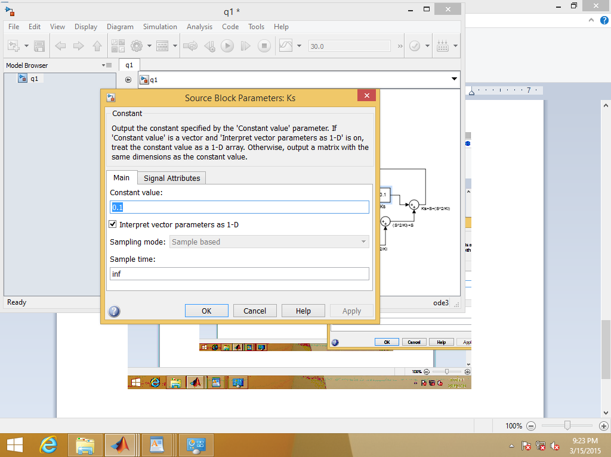

µm = 0.3 h-1

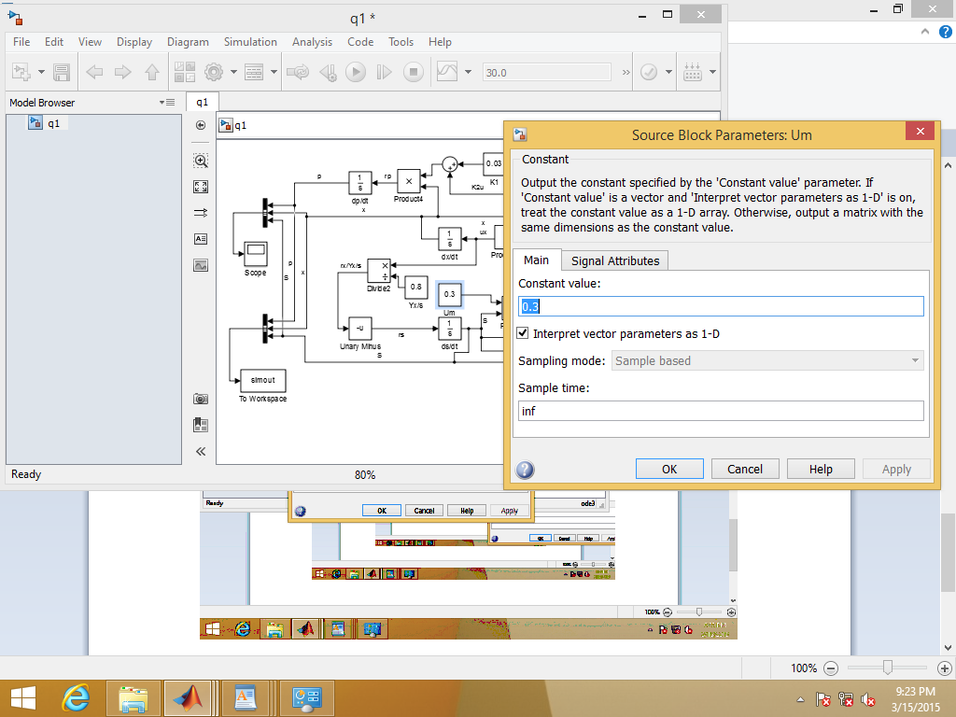

Yx/s = 0.8 kg X/kg

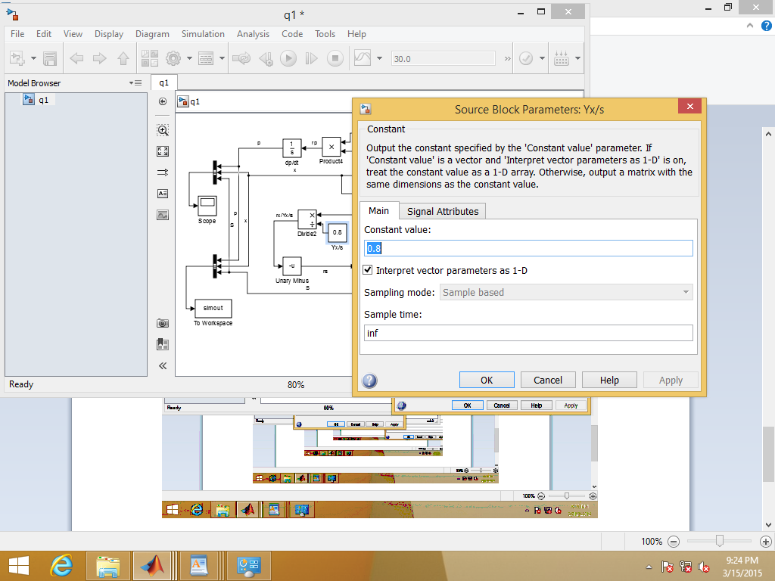

K2 = 0.08 kgP/kgX.h

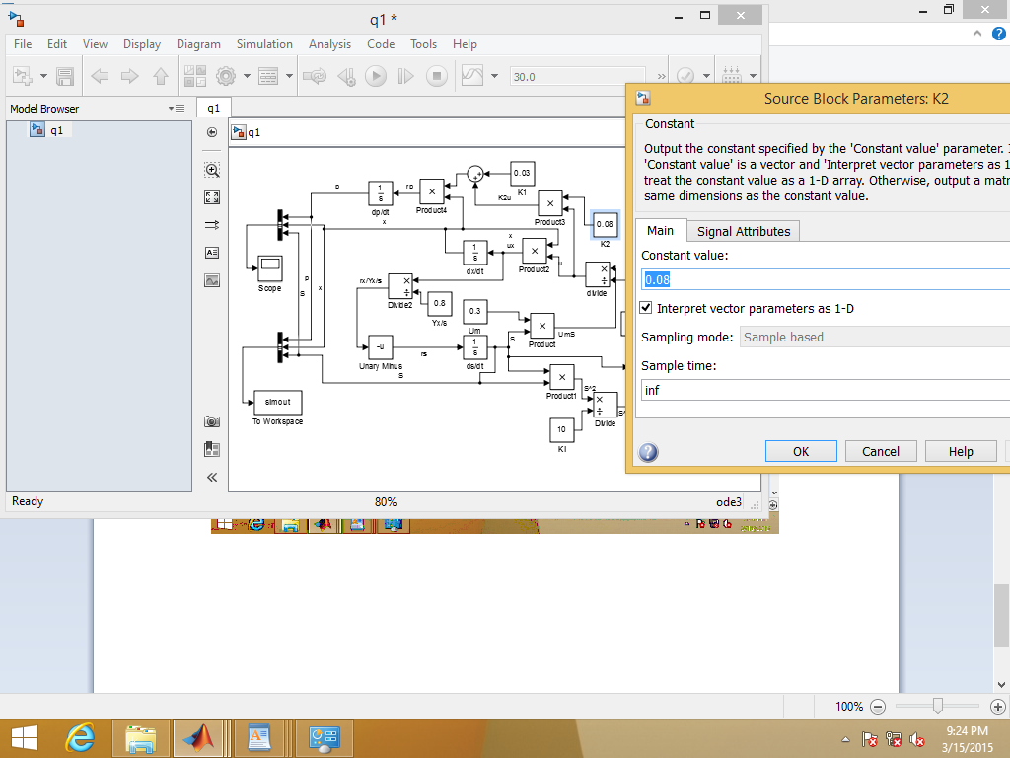

K1 = 0.03 kgP/kgX.h

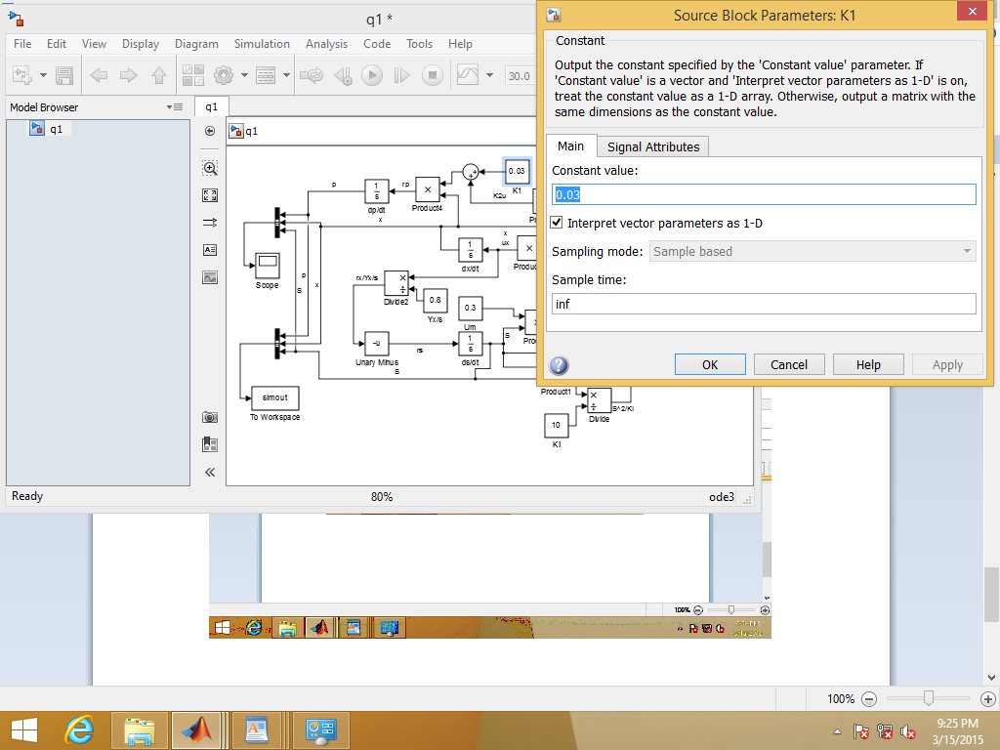

Next to define the identity $μ= \frac{μ_{m}S}{K_{s}+S+\frac{S^{2}}{K_{i}}}$

$μ_{m}S$ was formed as a product of the constant block Um and the output of the integrator ds/dt

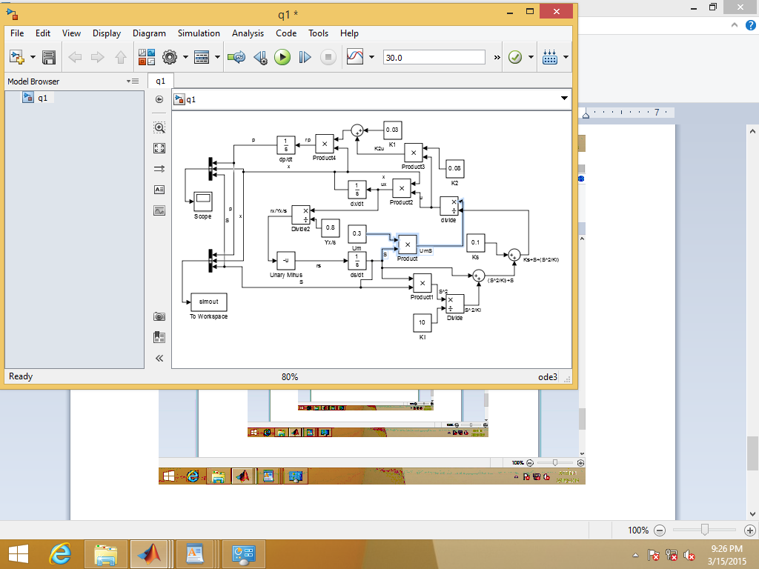

$S^{2}$ was formed by the multiplying the product of the integrator block ds/dt by itself

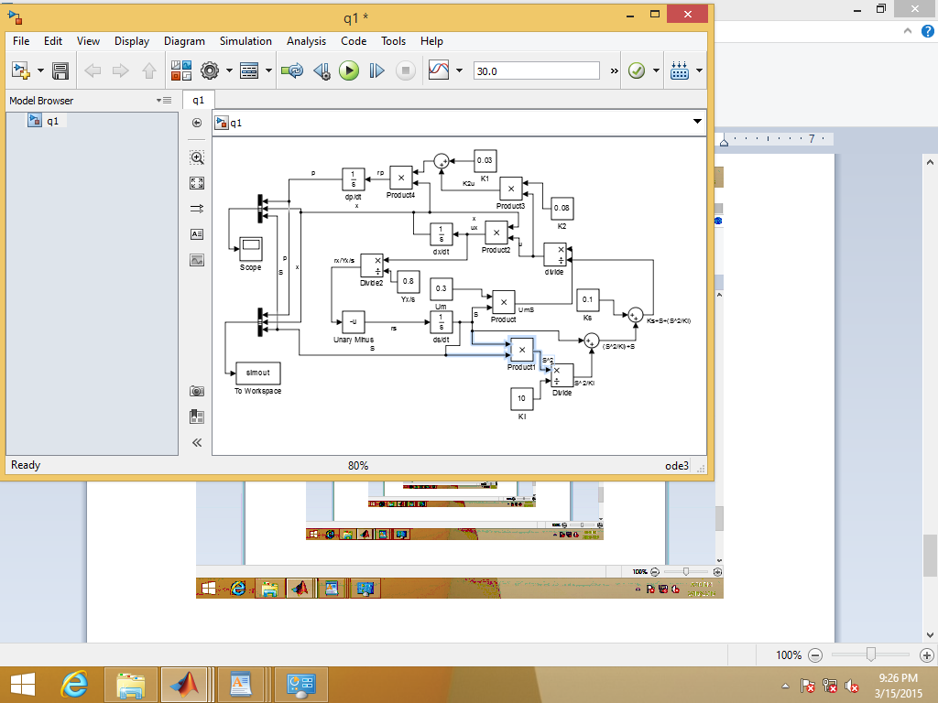

$\frac{S^{2}}{K_{i}}$ was formed by dividing this product by the constant block Ki

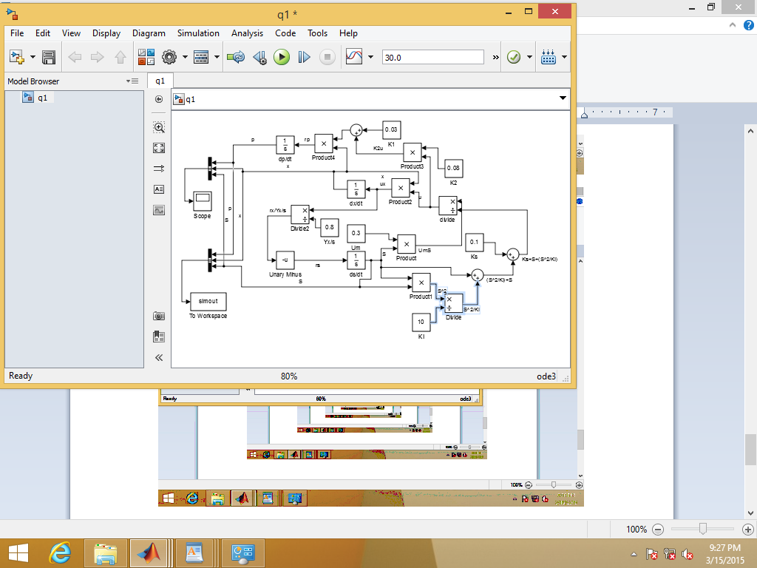

was formed by the summation of this operation with the output of the integrator block ds/dt

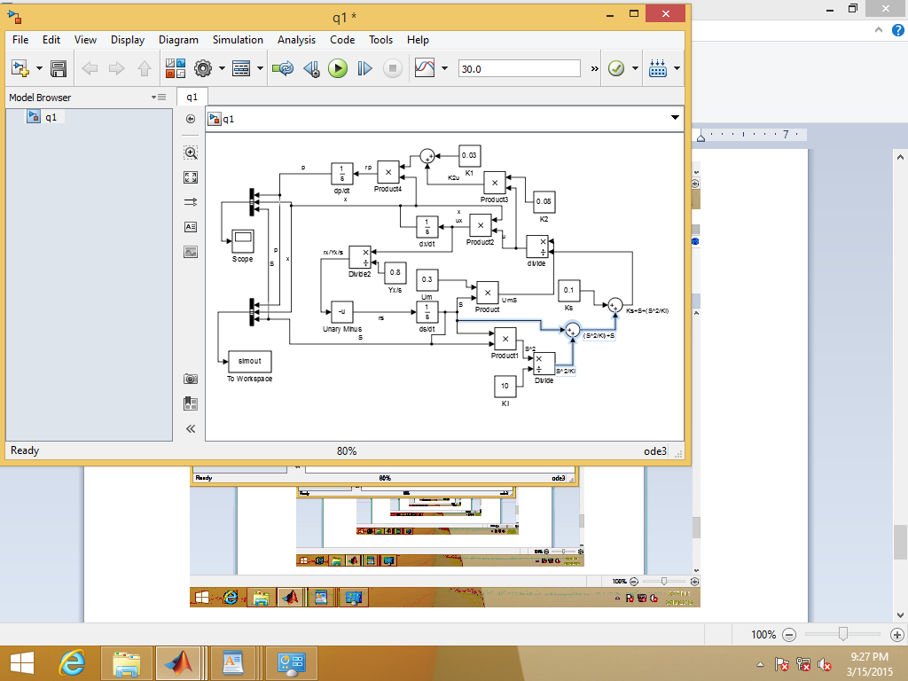

$K_{s}+S+\frac{S^{2}}{K_{i}}$ was formed by the summation of this product with the constant block Ks

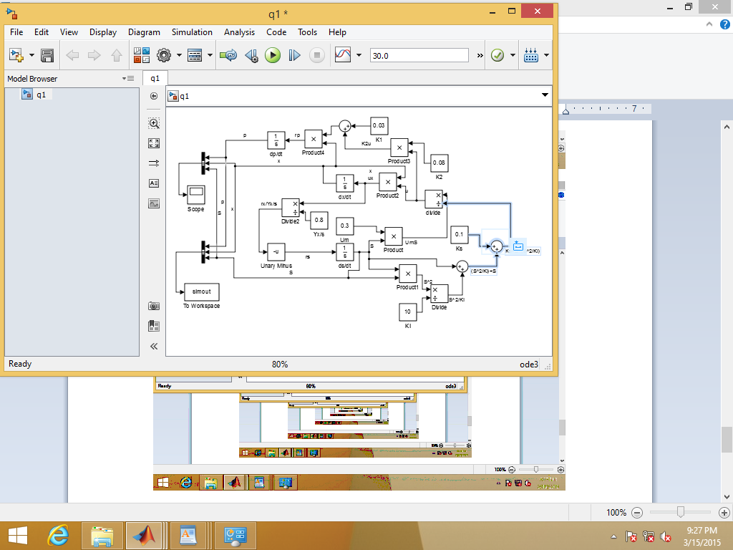

The output $μ_{m}S$ was then divided by this stream to provide $μ$

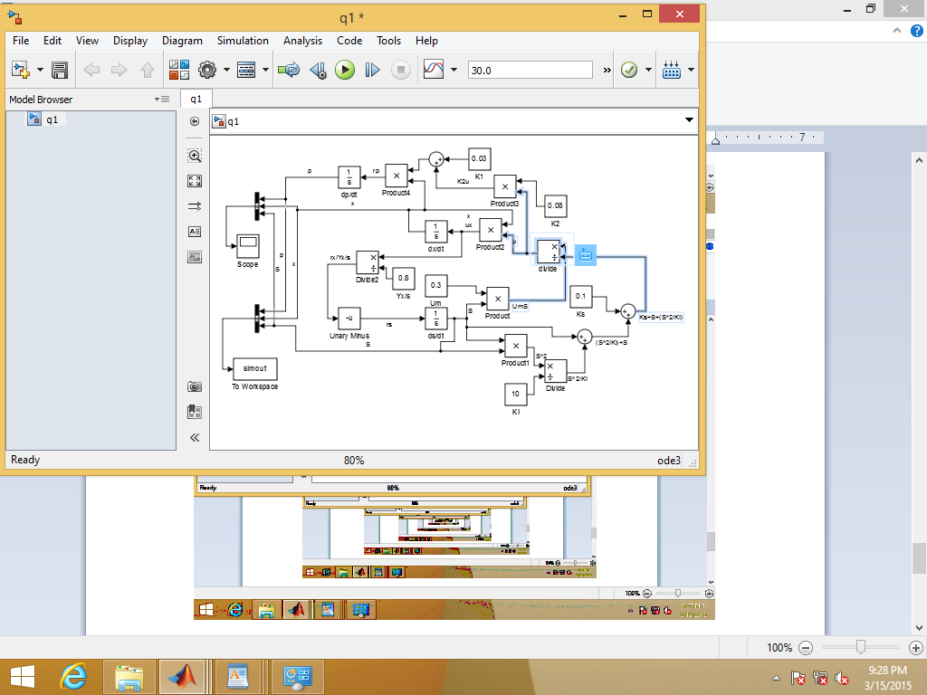

To find the identity ${ r}_{X}=μX$ μ was multiplied by the output of the integrator block dx/dt

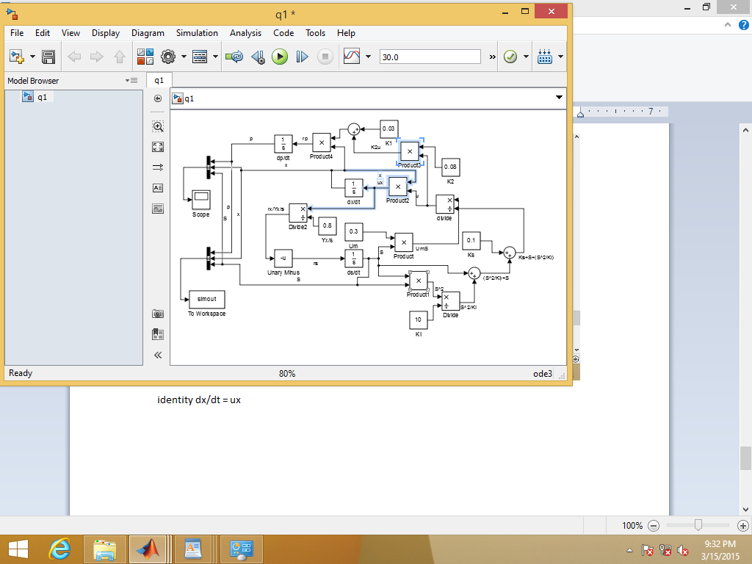

To find the identity $r_{s}=-\frac{r_{X}}{Y_{X/s}}$ the μx stream was divided by the constant block Yx/s

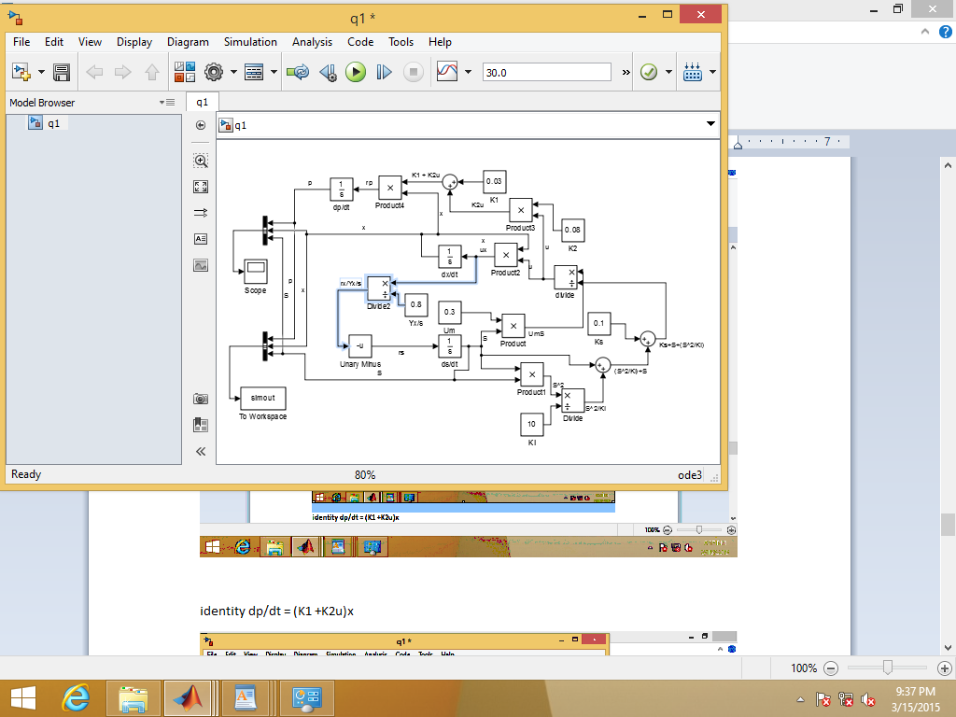

This stream was then input through the unary minus box to turn it into a negative.

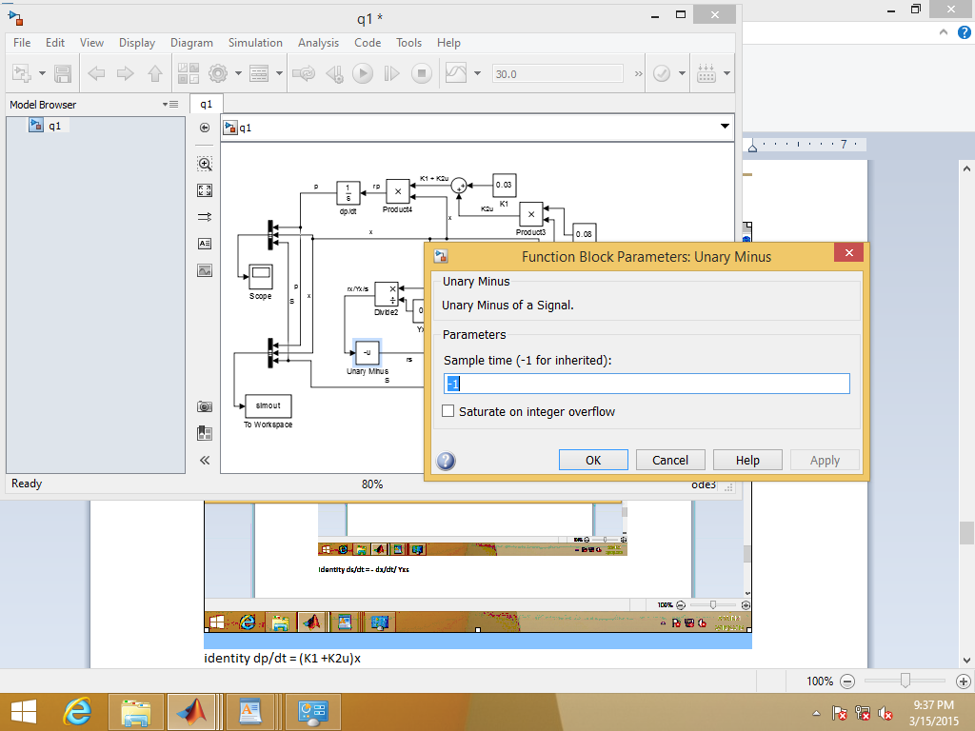

Next to find the identity $r_{p}=\left(K_{1}+K_{2}μ\right)X$ first the K2 constant block was multiplied by μ to produce $K_{2}μ$

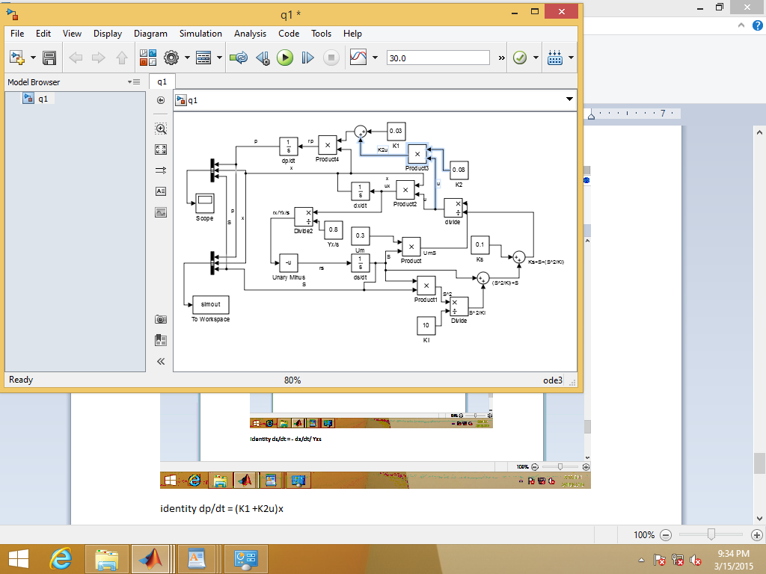

Next this stream output was summated with the K1 constant block to give $K_{1}+K_{2}μ$

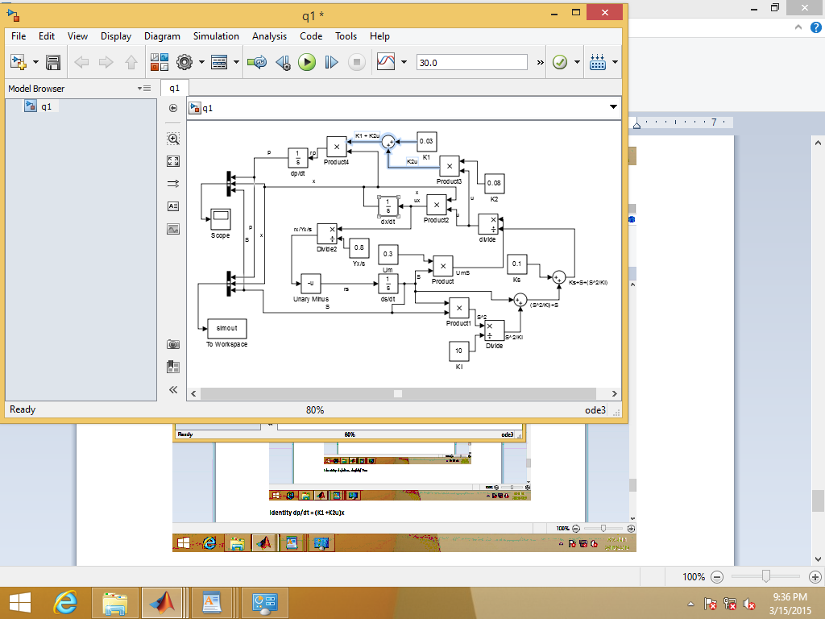

Next this was multiplied by the output of the dx/dt integrator block to give $r_{p}=\left(K_{1}+K_{2}μ\right)X$

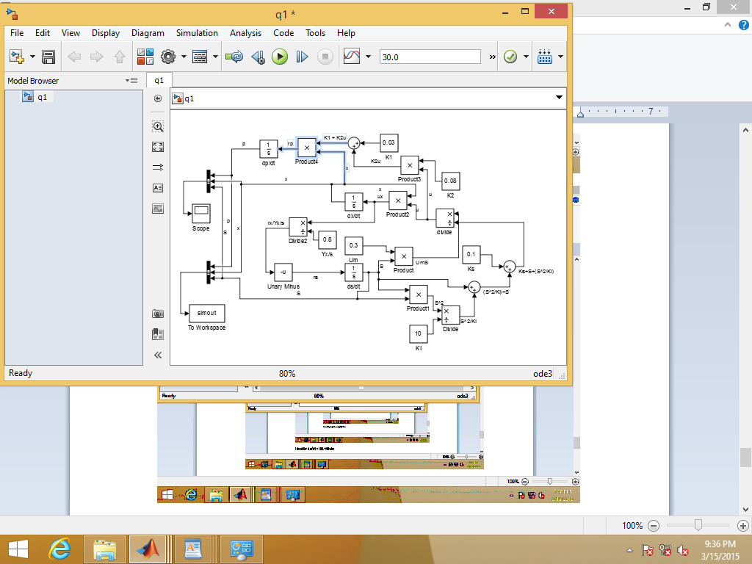

Next X, S, and P streams were directed to Simout and the data was presented as an array

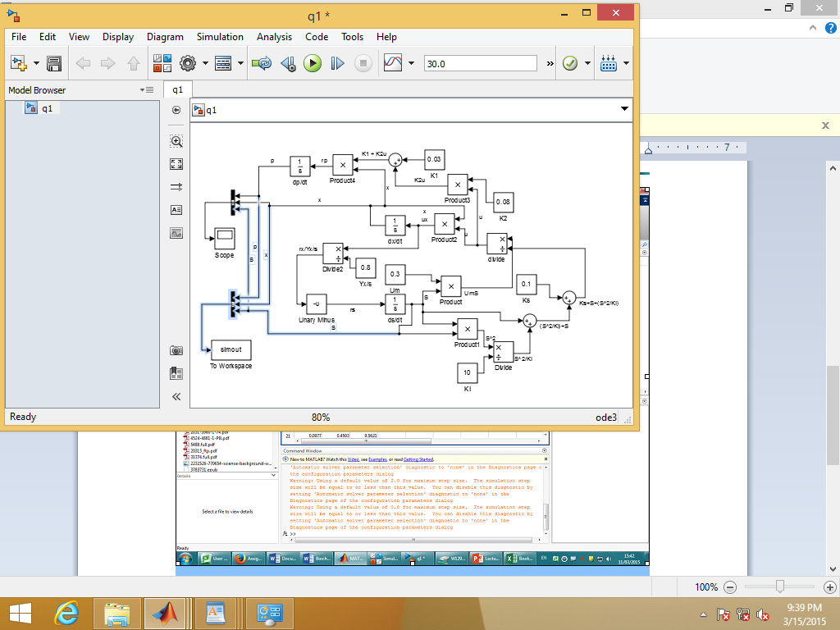

Simout to array

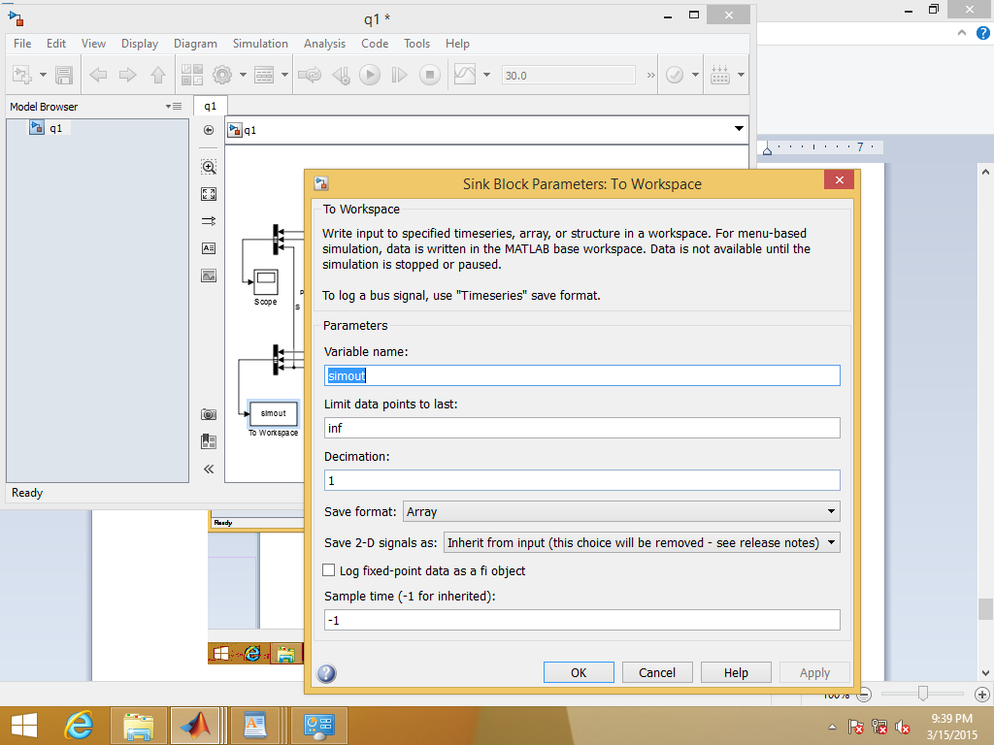

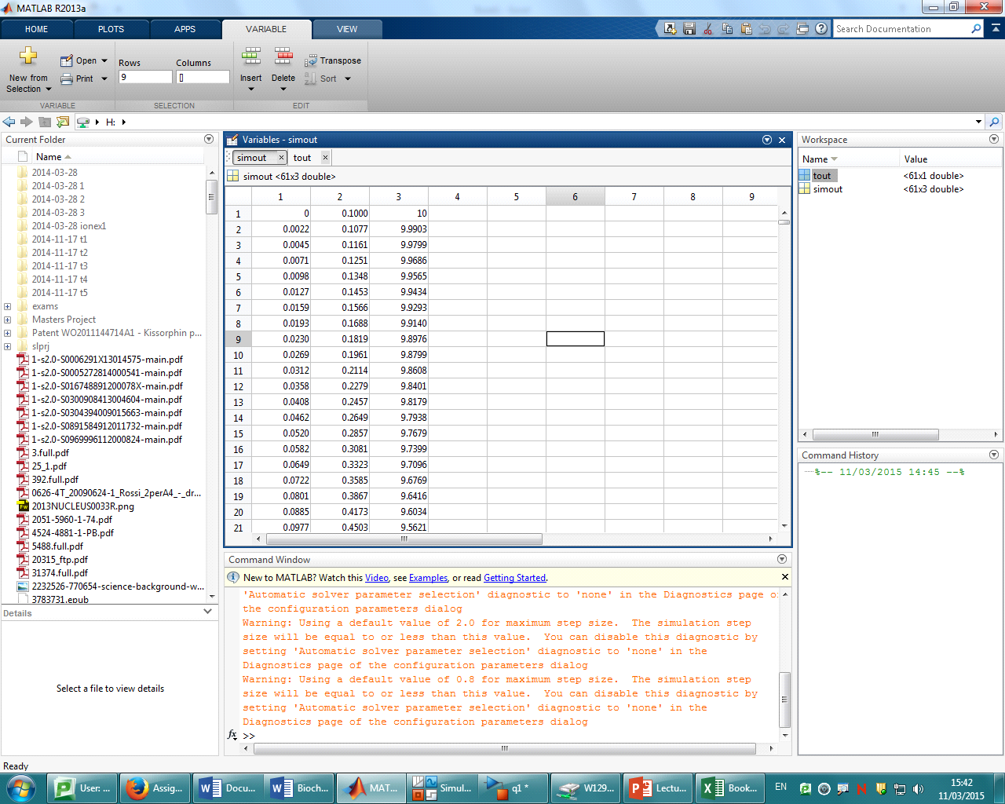

A plot of substrate concentration against time shows substrate runs out at 26.5 hours

Biomass concentration when substrate runs out can be calculated from Yx/s as 0.8 * 10 = 8 kg/m3. This is in agreement with the graph shown above.

Product concentration at 30 hours remains the same as when substrate runs out at around 1.8 kg/m3

**Part 2**

When initial substrate concentration is increased some substrate inhibition occurs as can be seen in the denominator which possesses a higher order S term than in the numerator $μ= \frac{μ_{m}S}{K_{s}+S+\frac{S^{2}}{K_{i}}}$.

It thus is expected that it should take longer for the same product concentration to be reached when the initial condition of the substrate is placed at 20.

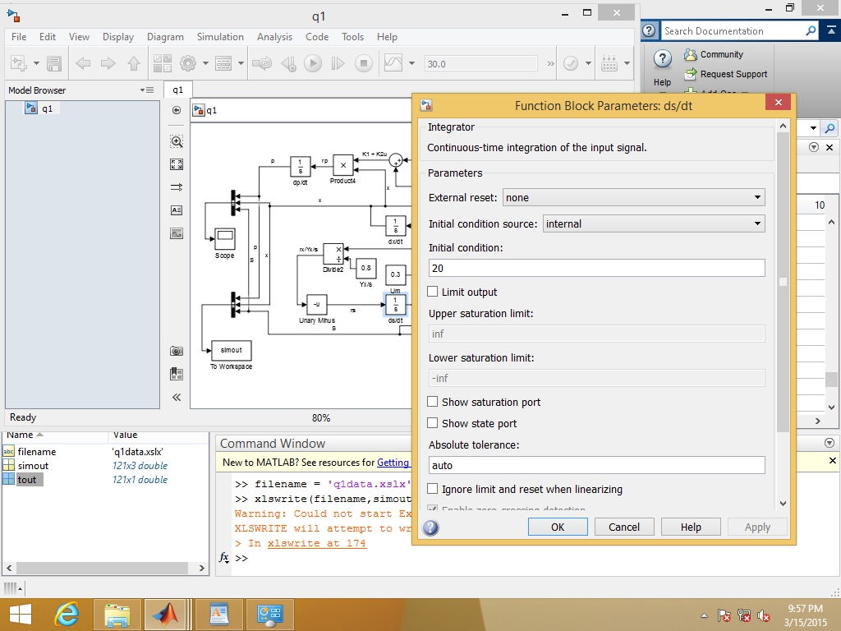

The same product concentration is reached at 37 hours

**Question 2**

Equation was defined and a graph plotted with initial value of Kp = 1

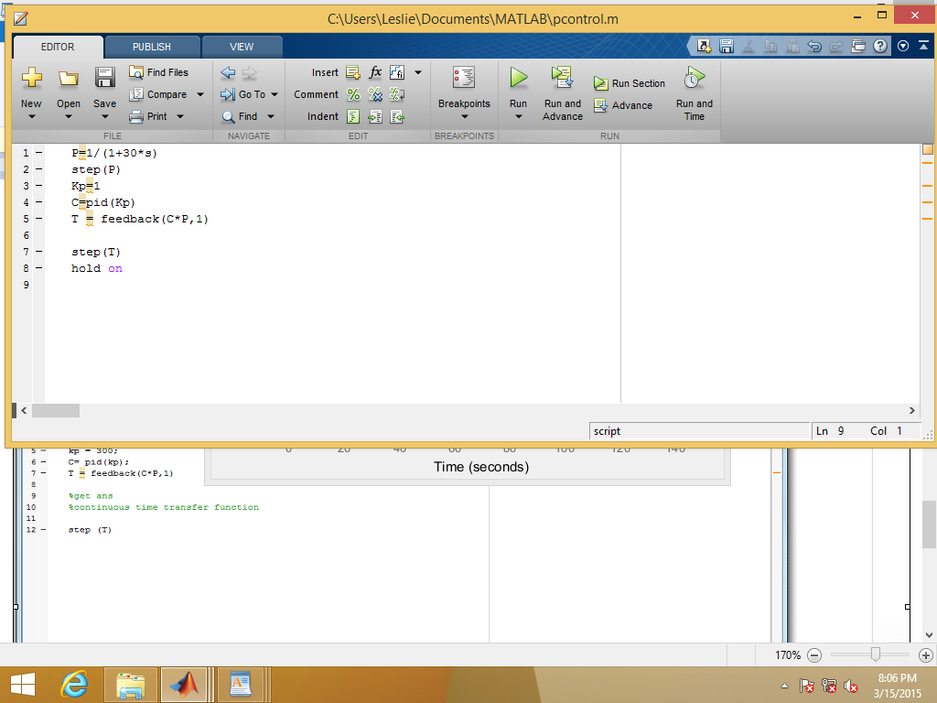

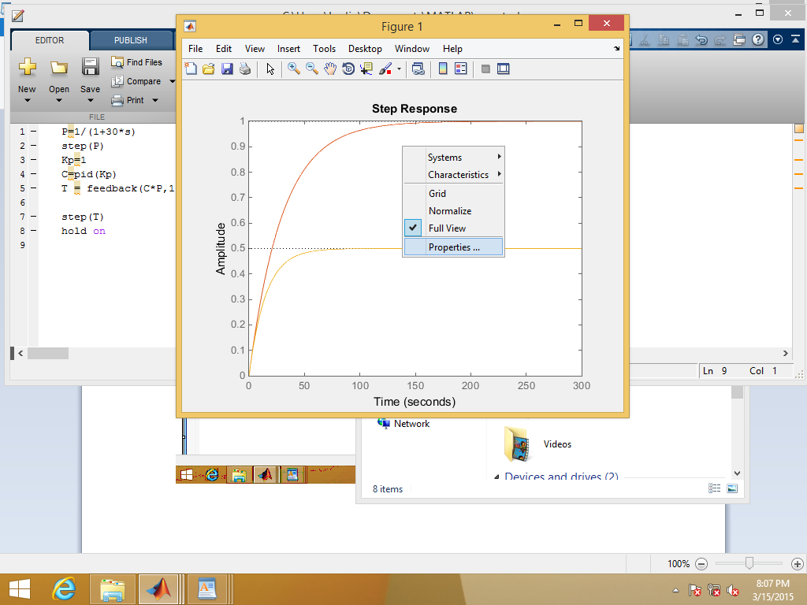

Settling time was then defined as 95% before being displayed on the graph

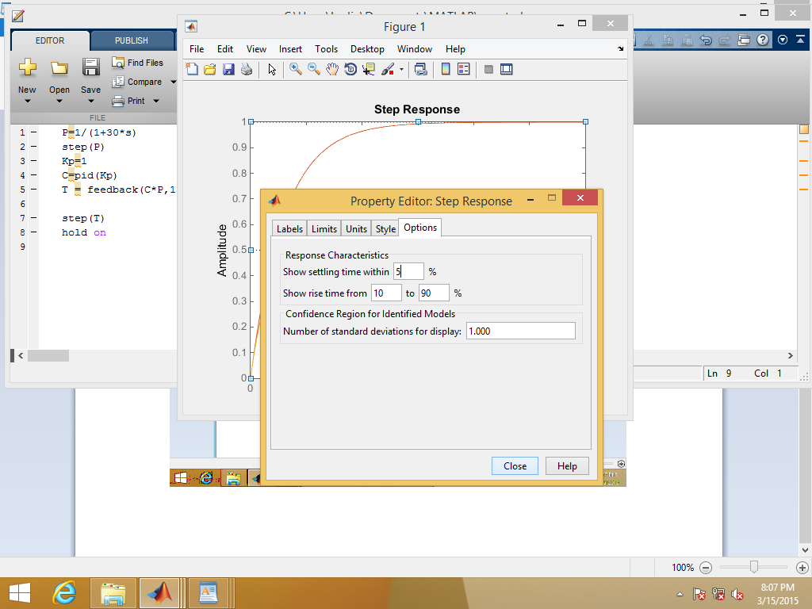

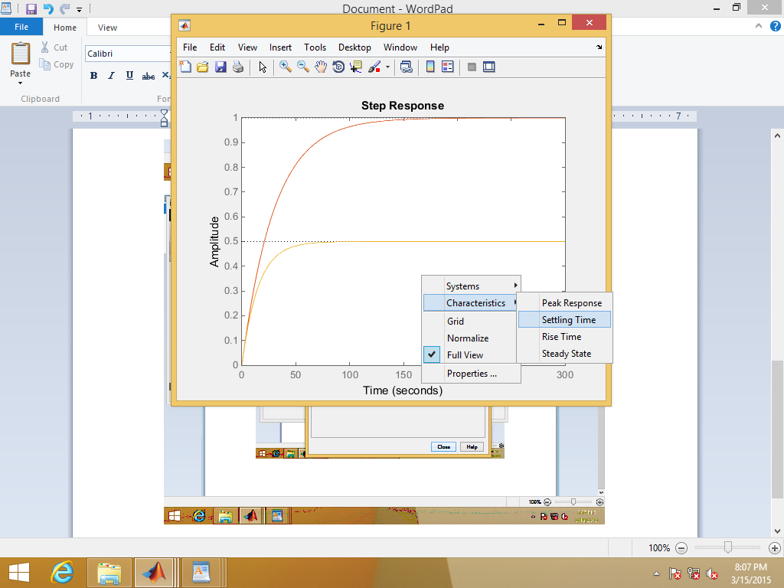

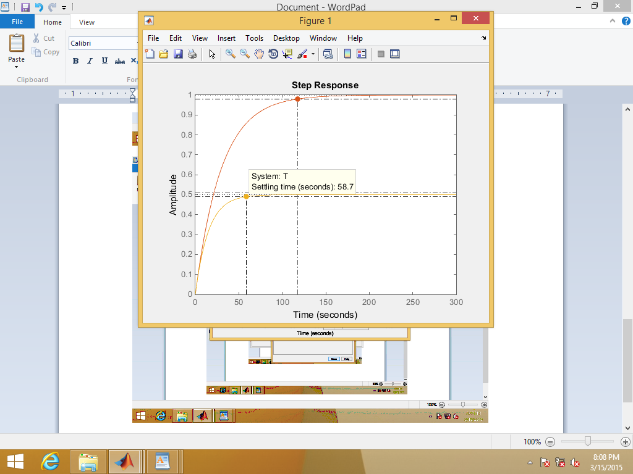

Increments of +1 were added to find a settling time close to 15 minutes

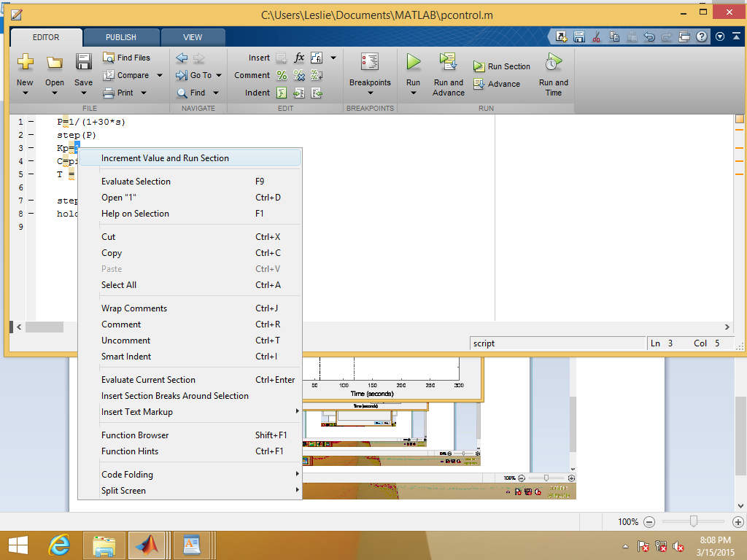

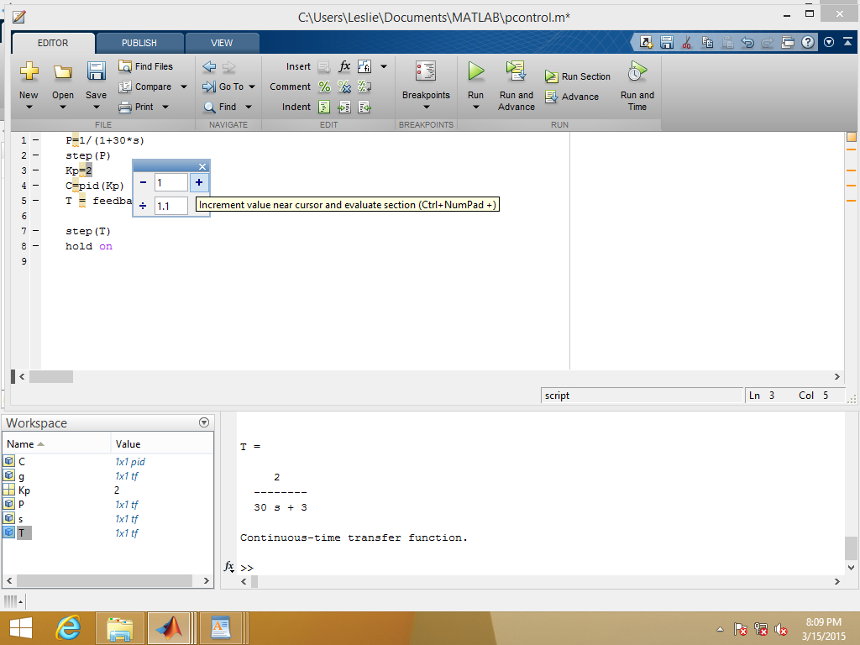

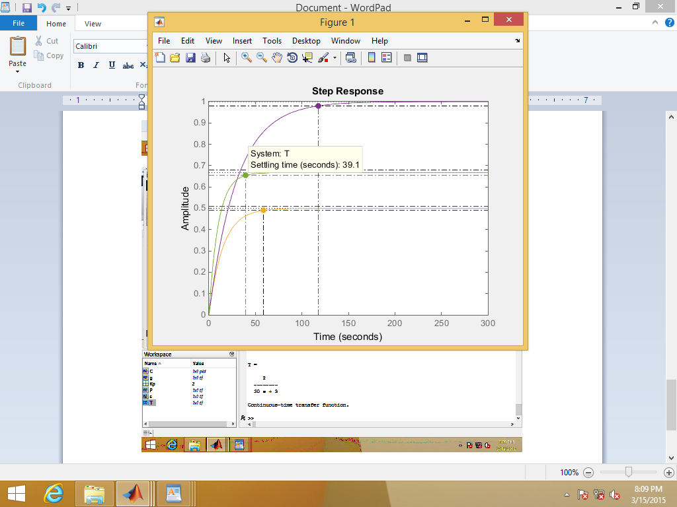

At Kp =7 settling time was 14.7 minutes, so increment size was changed to 0.1 and Kp down-shifted

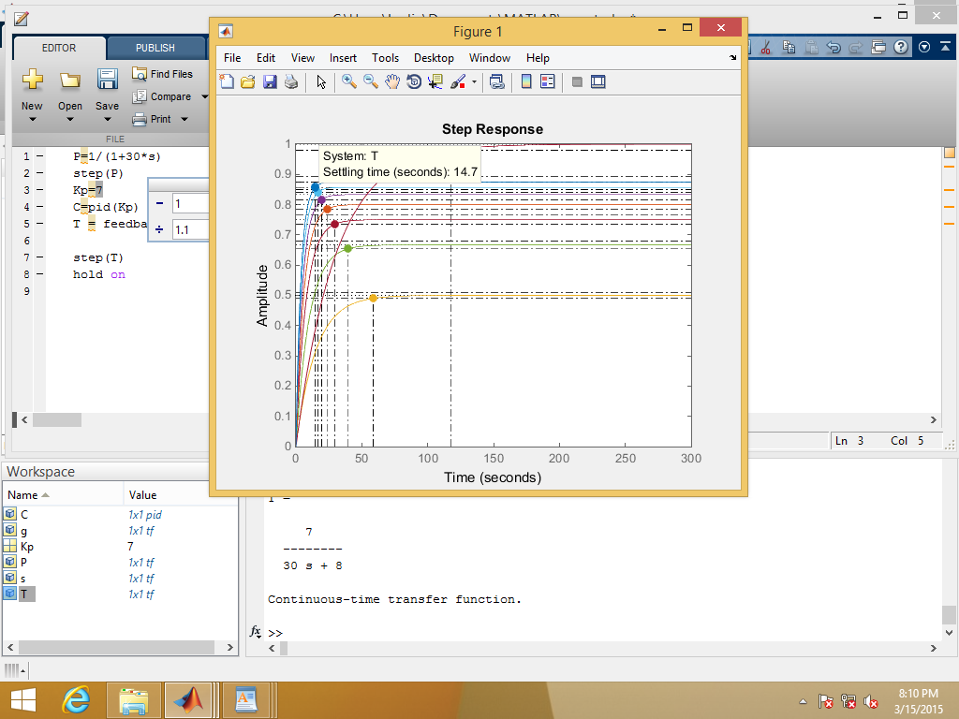

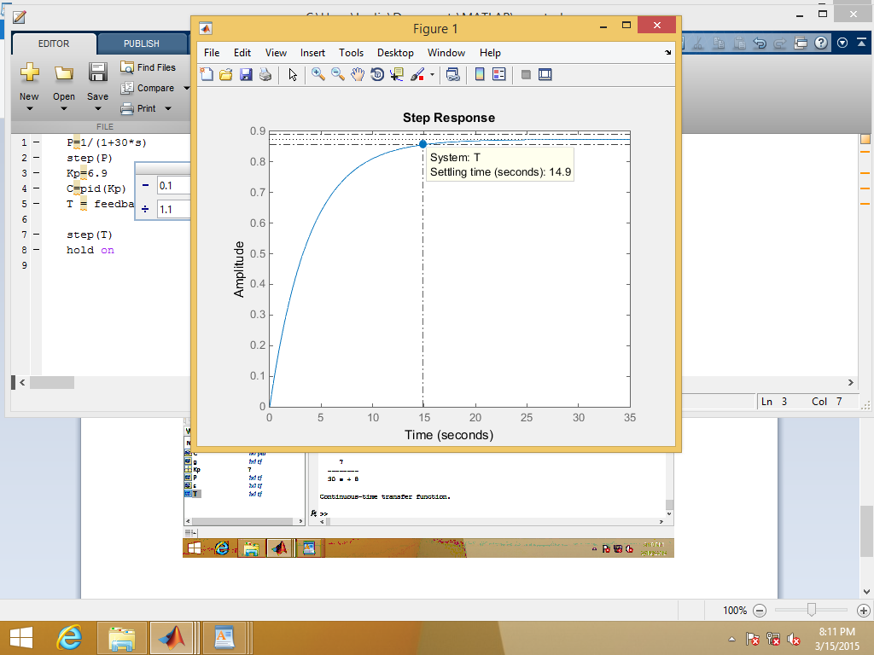

Kp value was found to produce a settling time of 15minutes at a value of 6.8

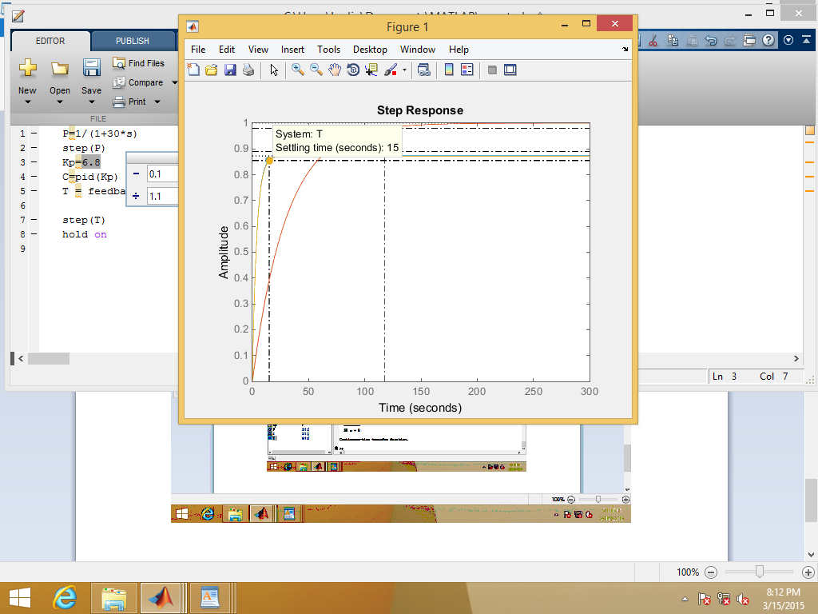

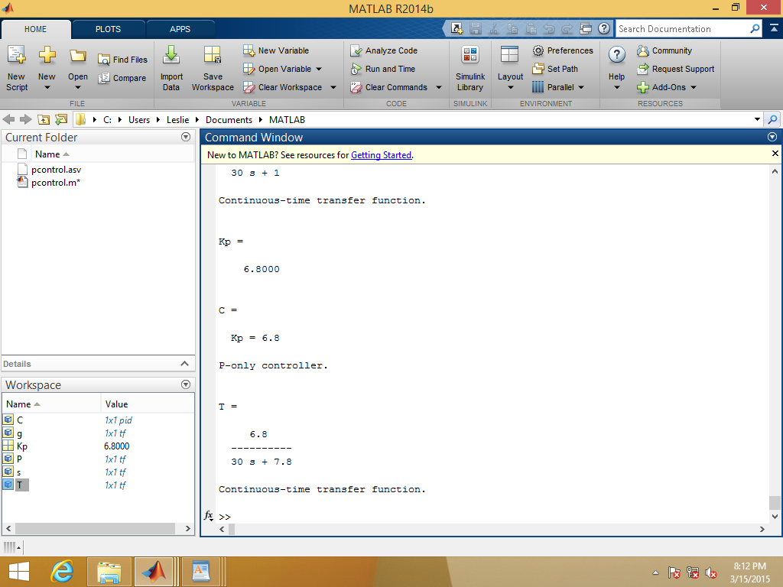

Therefore Kp value >6.8 if settling time 95% for settling time < 15 minutes

**Question 3**

First the diagram of the process with appropriate streams was constructed. Inputs were the Biomass stream and Air. Outputs were the product stream and vent

## 

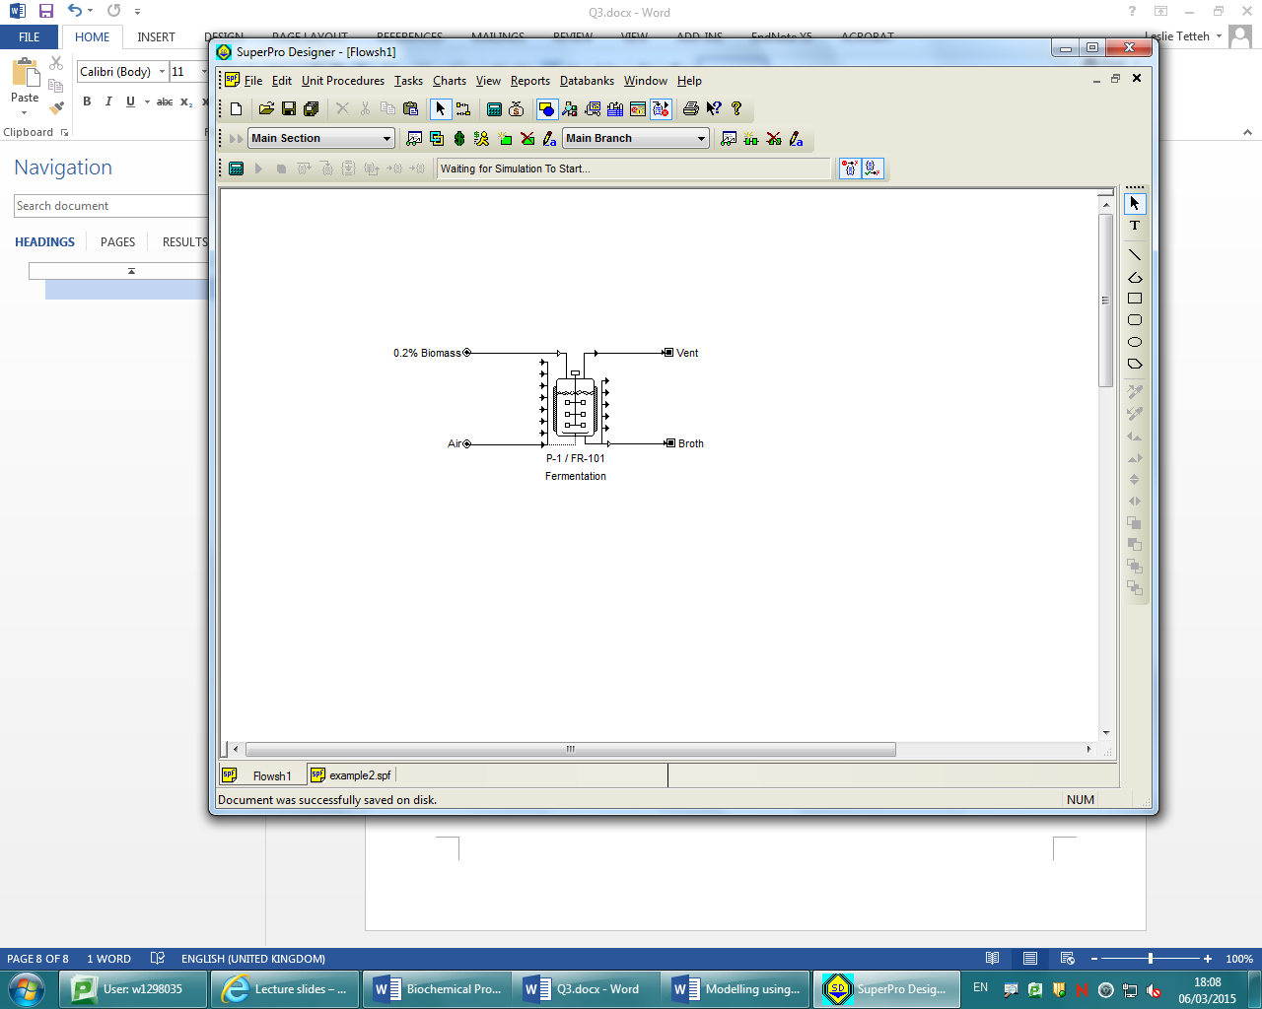

Components were then specified which were Biomass, Glucose and carbon dioxide. The MW of Biomass was defined as 44.01 g/mol

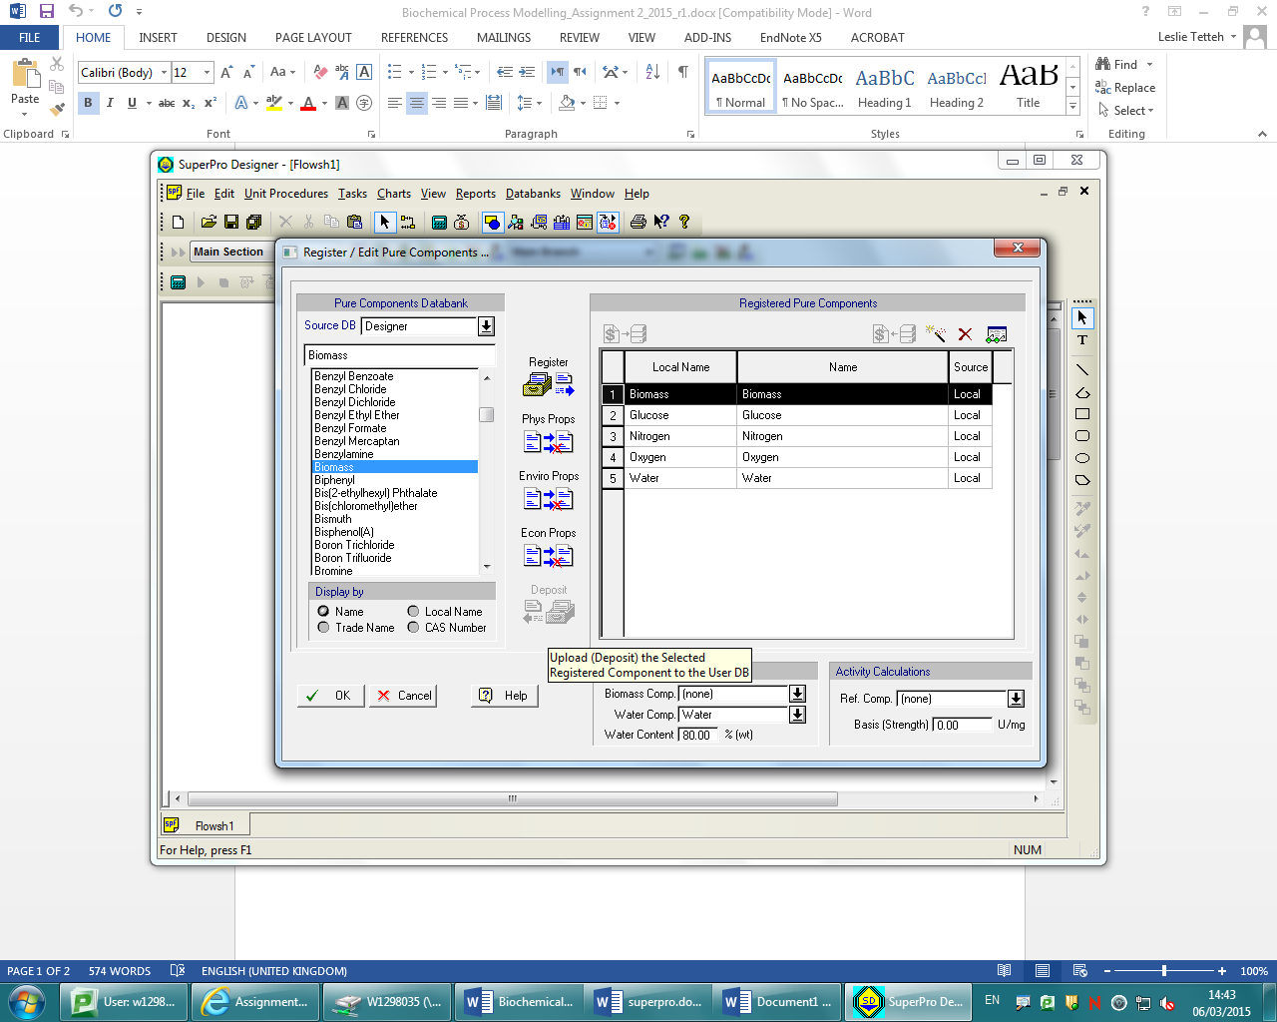

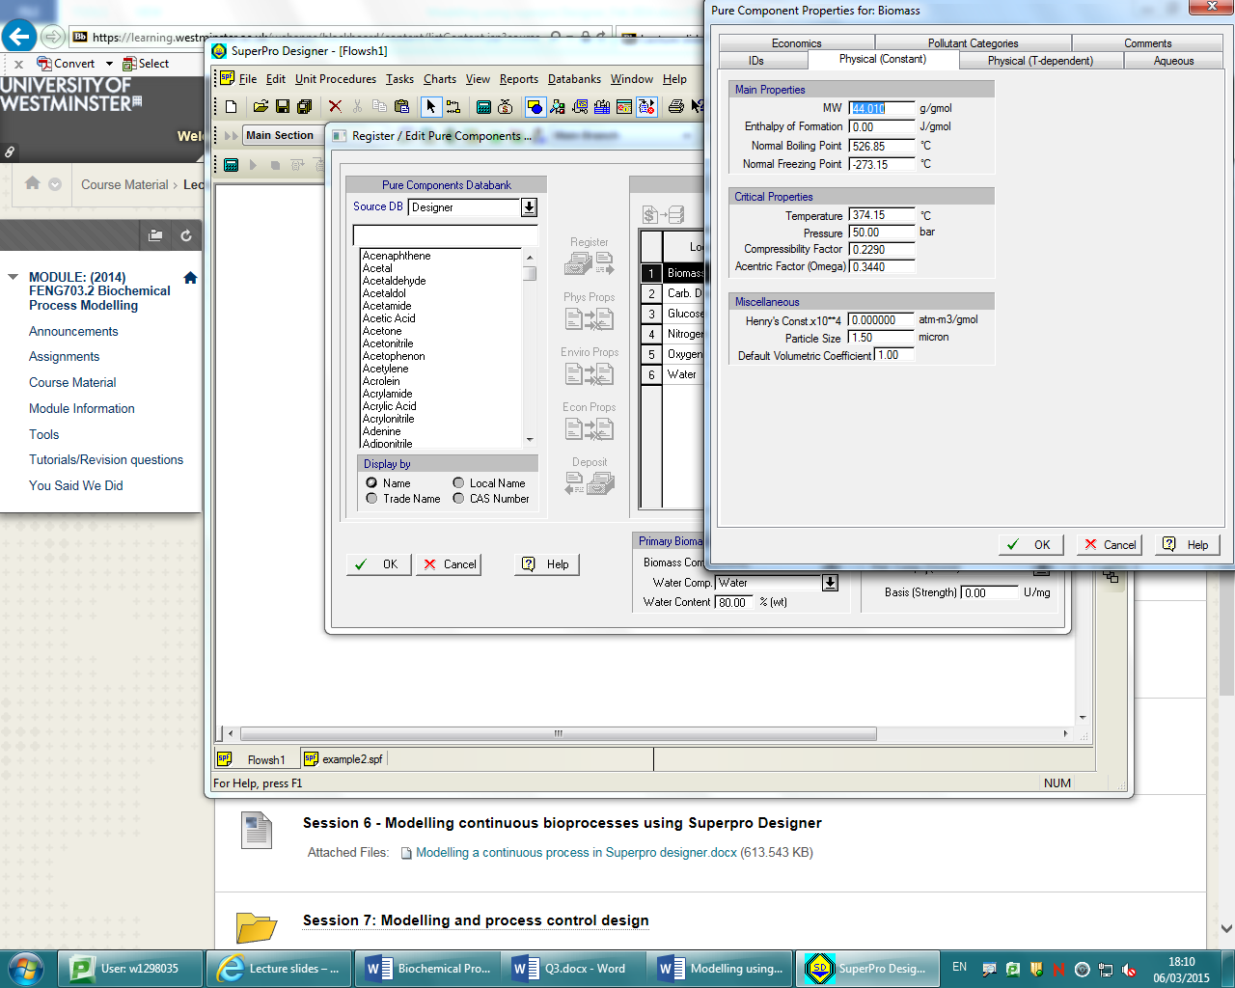

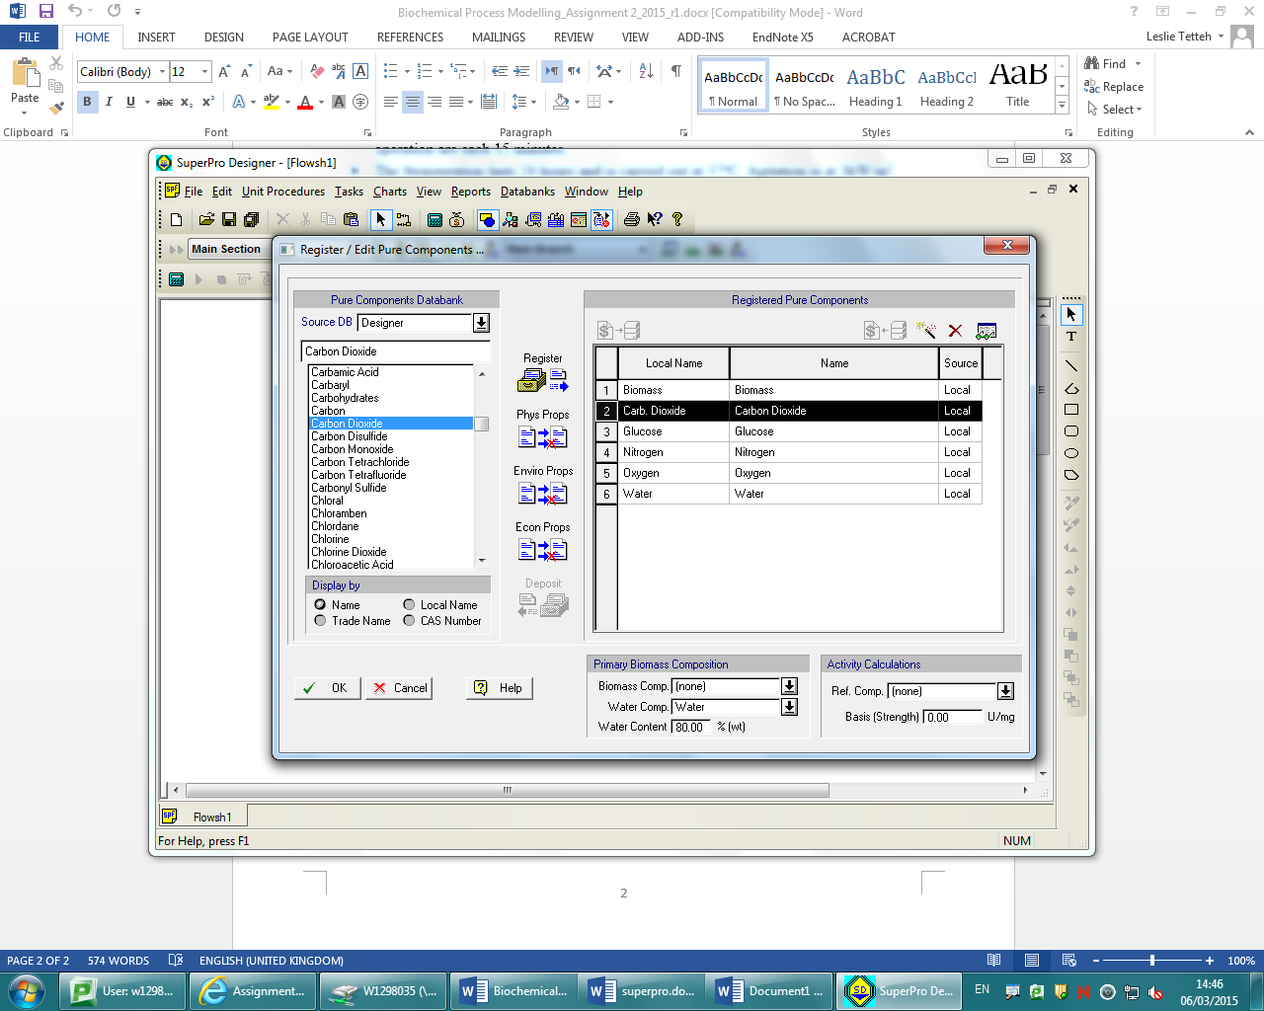

Next the mass composition of the biomass stream was defined as 0.2% biomas, 9.8% glucose and 90% water. Similarly the air input stream was defined as air.

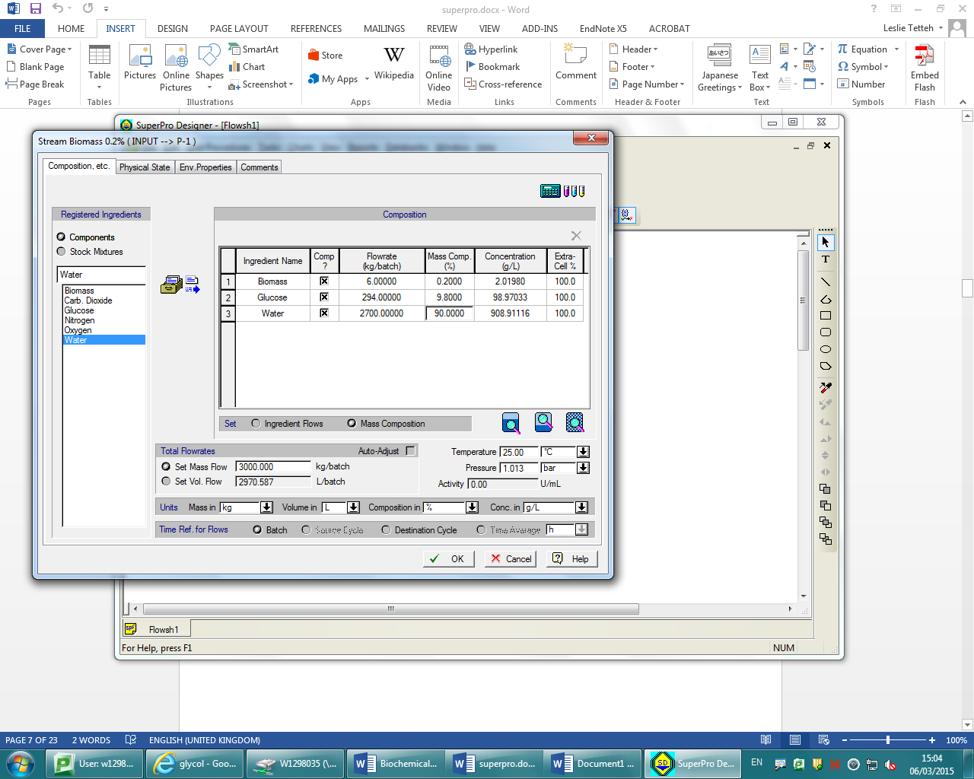

The first operation to take place was the charging of the biomass, the amount was defined as 3000kg/batch with a setup time and process time of 15 minutes each.

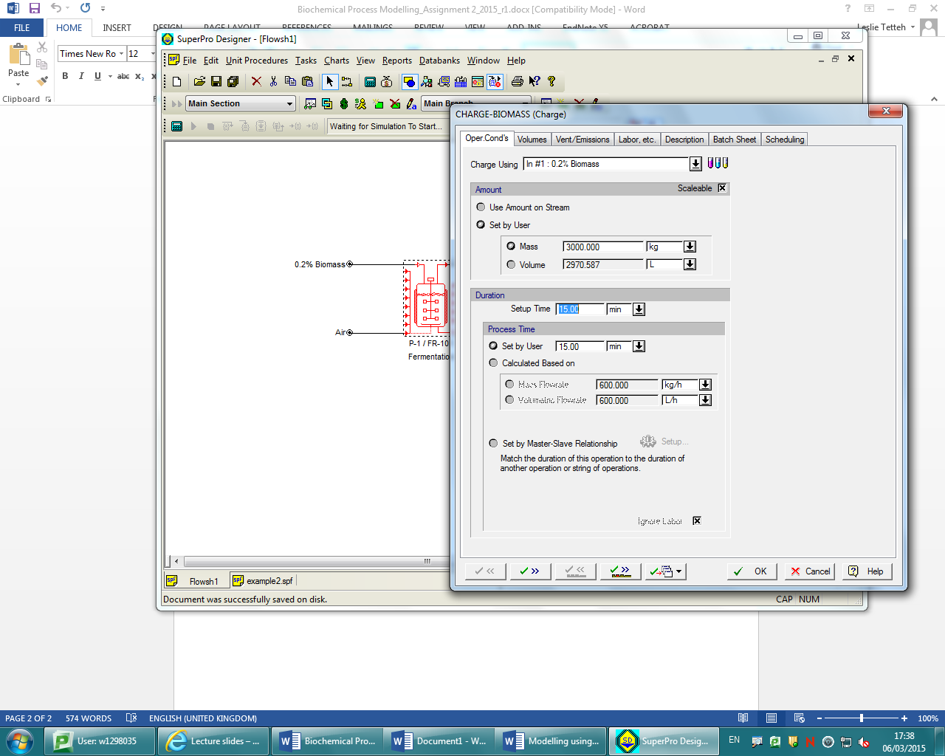

Next the agitation step was set up as a slave operation to the fermentation process itself.

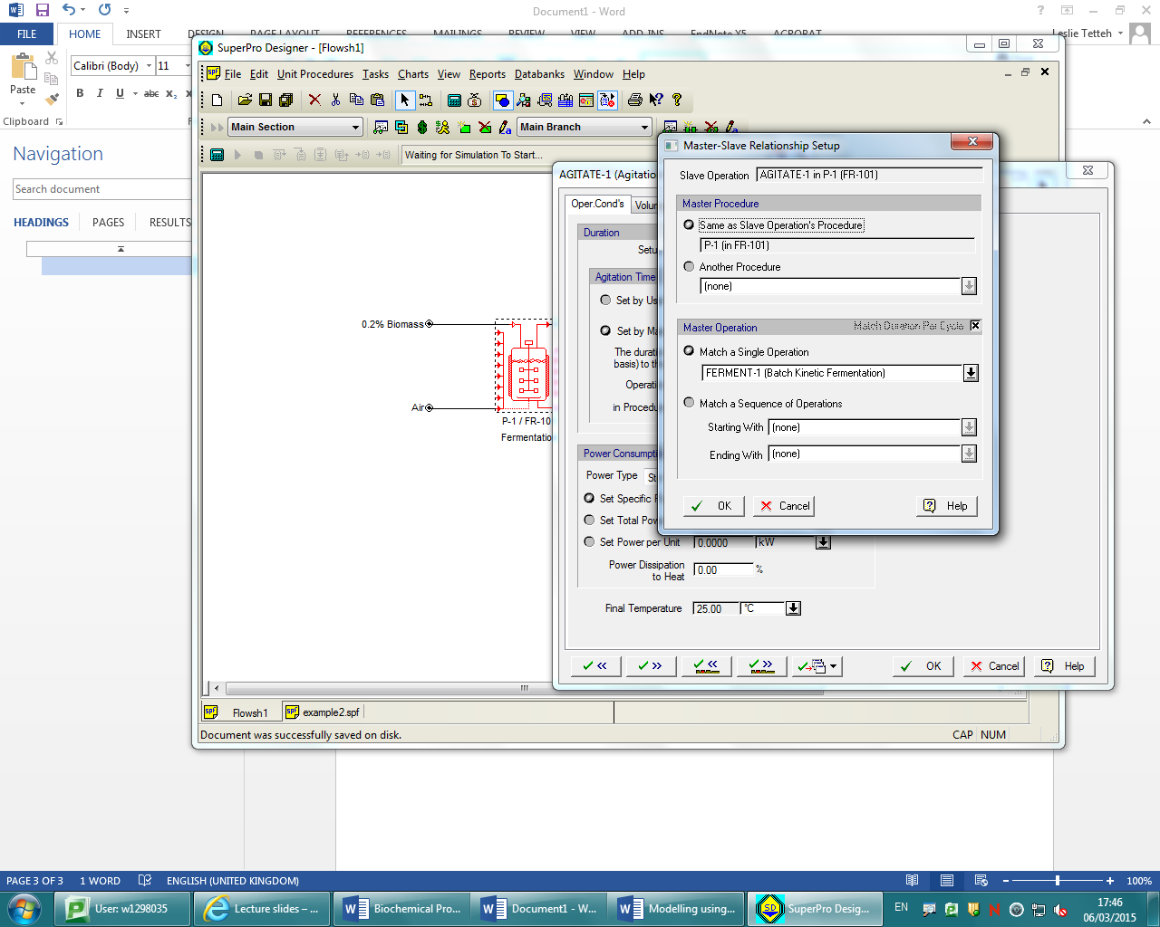

The specific power was set to 3 kW/m3

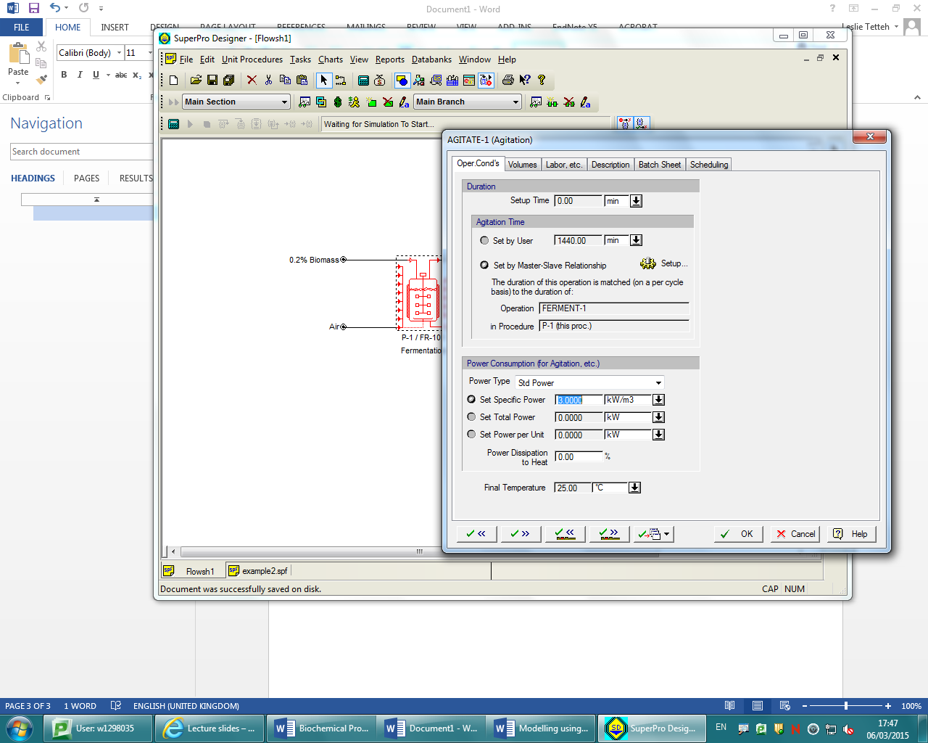

Next for the fermentation step the temperature was set at 37˚c, the air supply stream was set to air, the reaction time was set to 24 hours and the Air flowrate to 0.5vvm. The heat transfer agent was also set as chilled water.

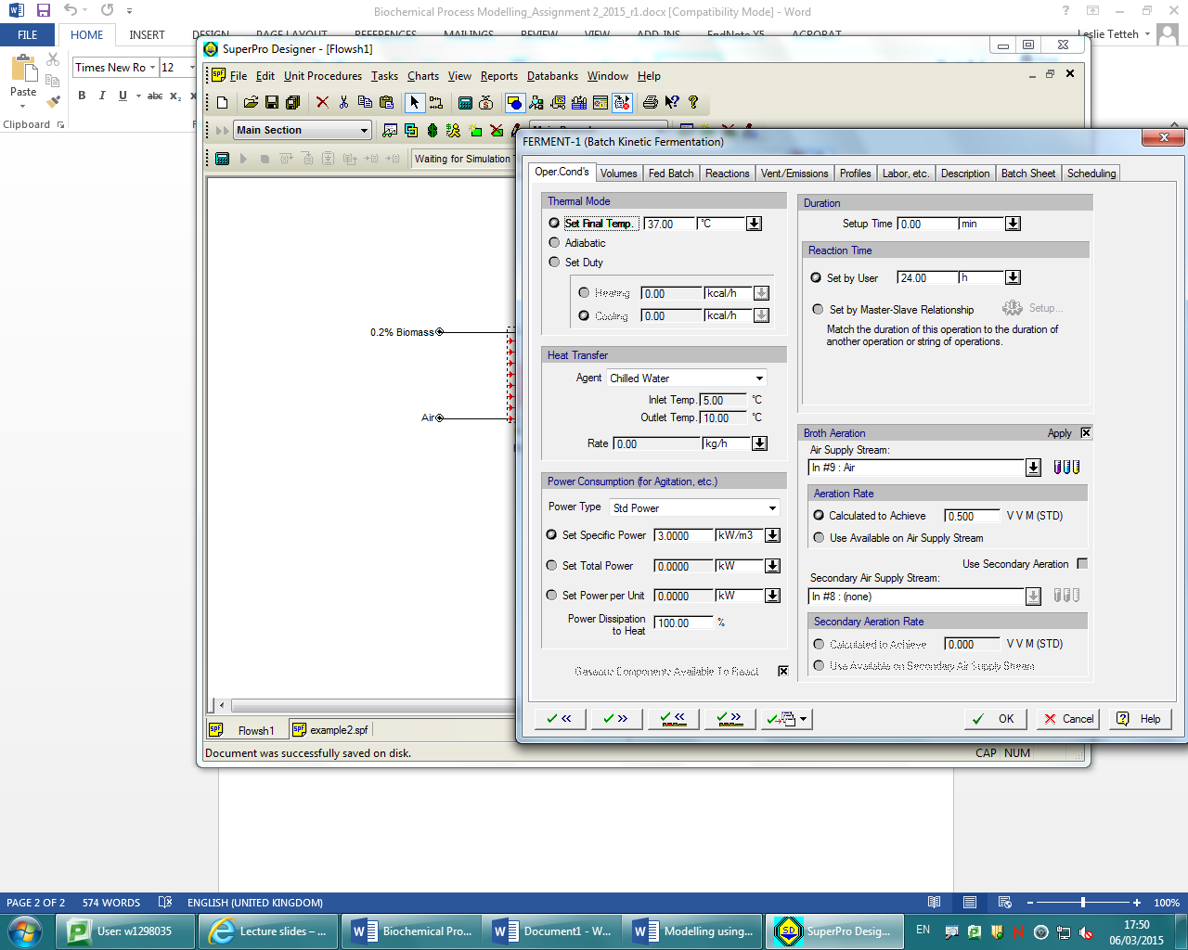

The max allowable volume in the reactor was then set to 90%

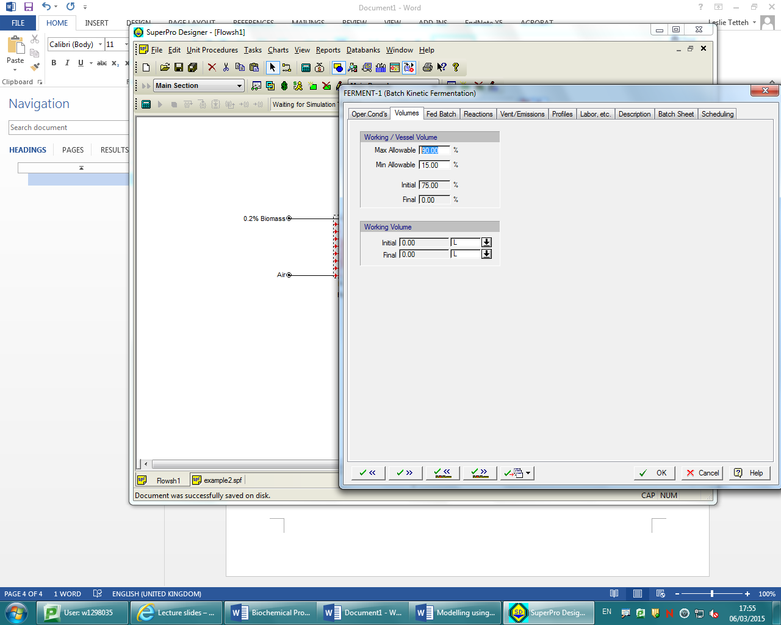

Next the enthalpy of reaction was set at -3700 kcal/kg

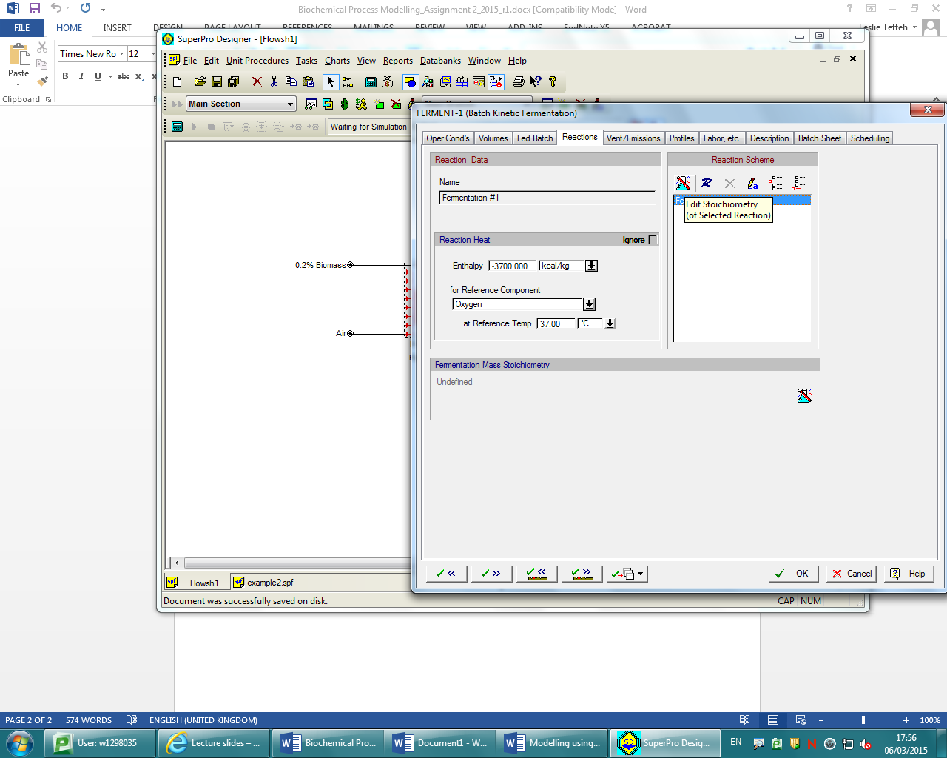

Molar co-efficients were then defined as 1 glucose + 6 oxygen => 2 Biomass + 4 CO2 + 6 H2O

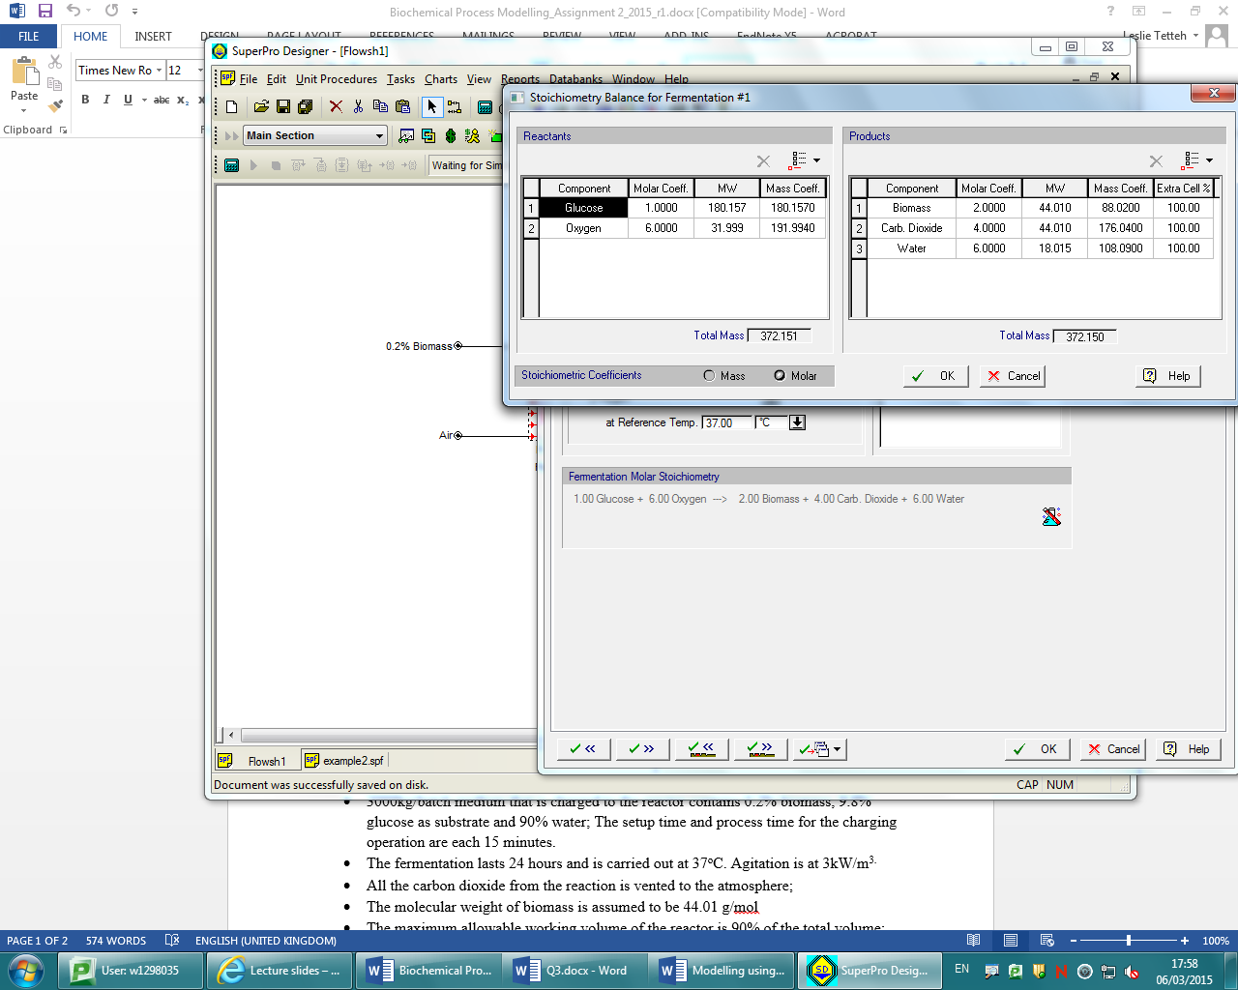

The reaction kinetics were then defined. Glucose as the main substrate and the rate reference component being biomass. Monod’s constant Ks was defined as 30mg/L and μmax as 0.25 h-1

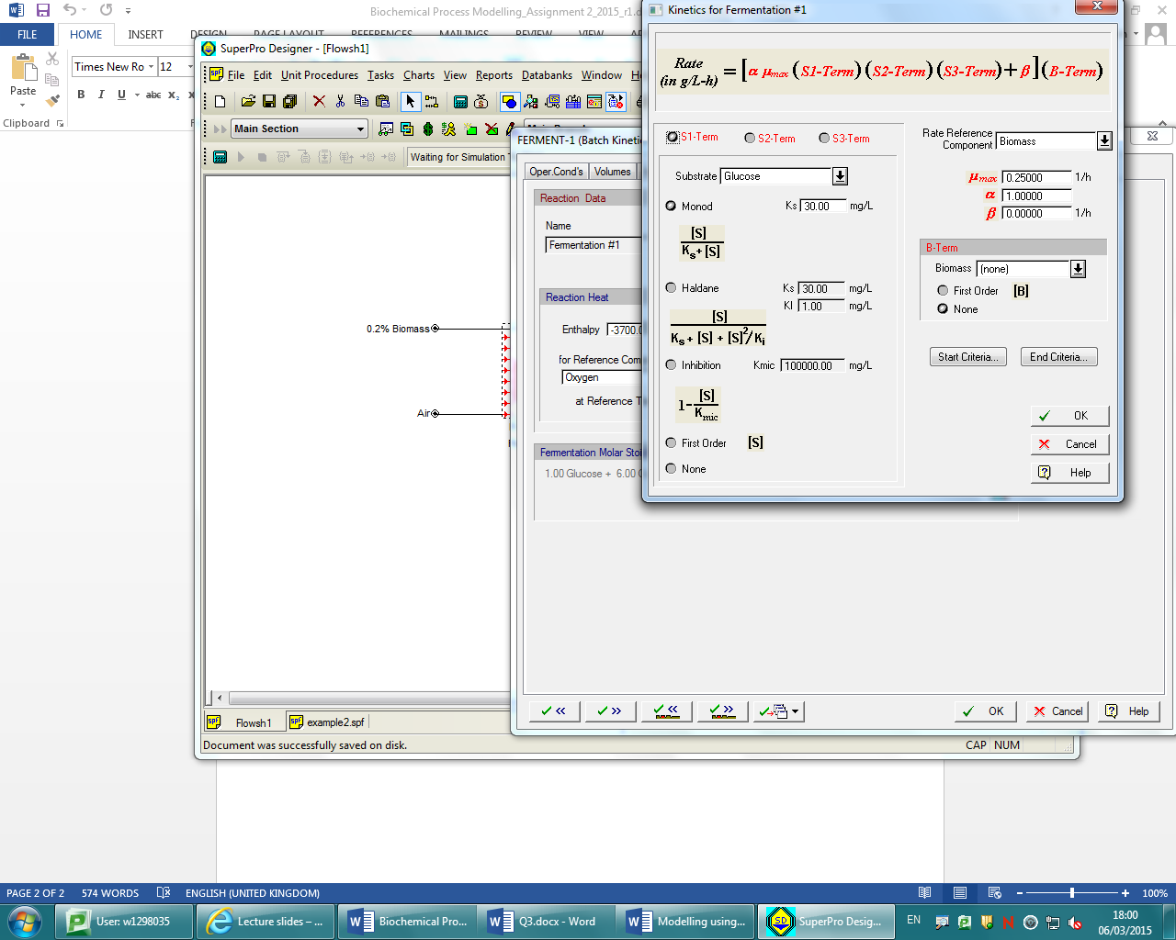

The vent stream was then set to vent 100% of carbon dioxide gas from the reaction, and the vent stream was selected as the output.

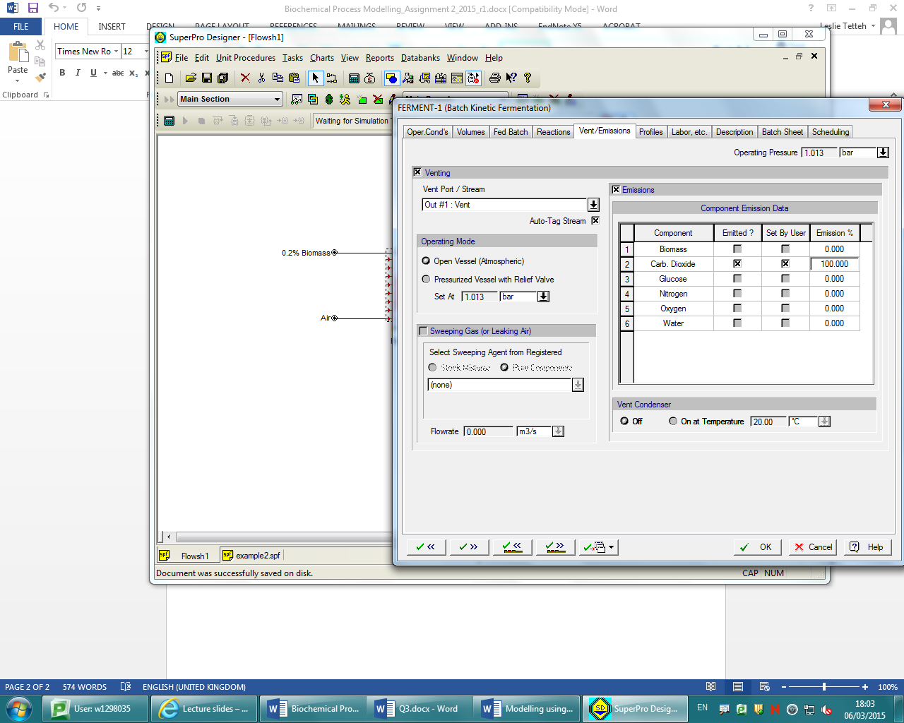

The next operation after reaction was cooling for which glycol was used with a final temperature of 5˚c and a cooling rate of 0.5˚c/min.

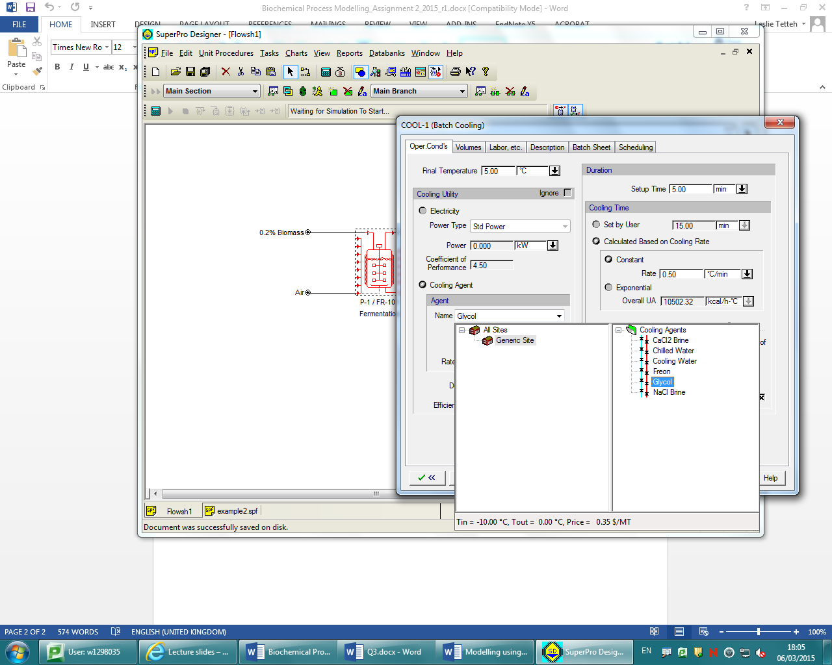

Next the transfer operation was defined, with the stream labelled ‘broth’ being selected for the transfer out operation. Total process time was 272 min and 100% of vessel contents were selected for transfer.

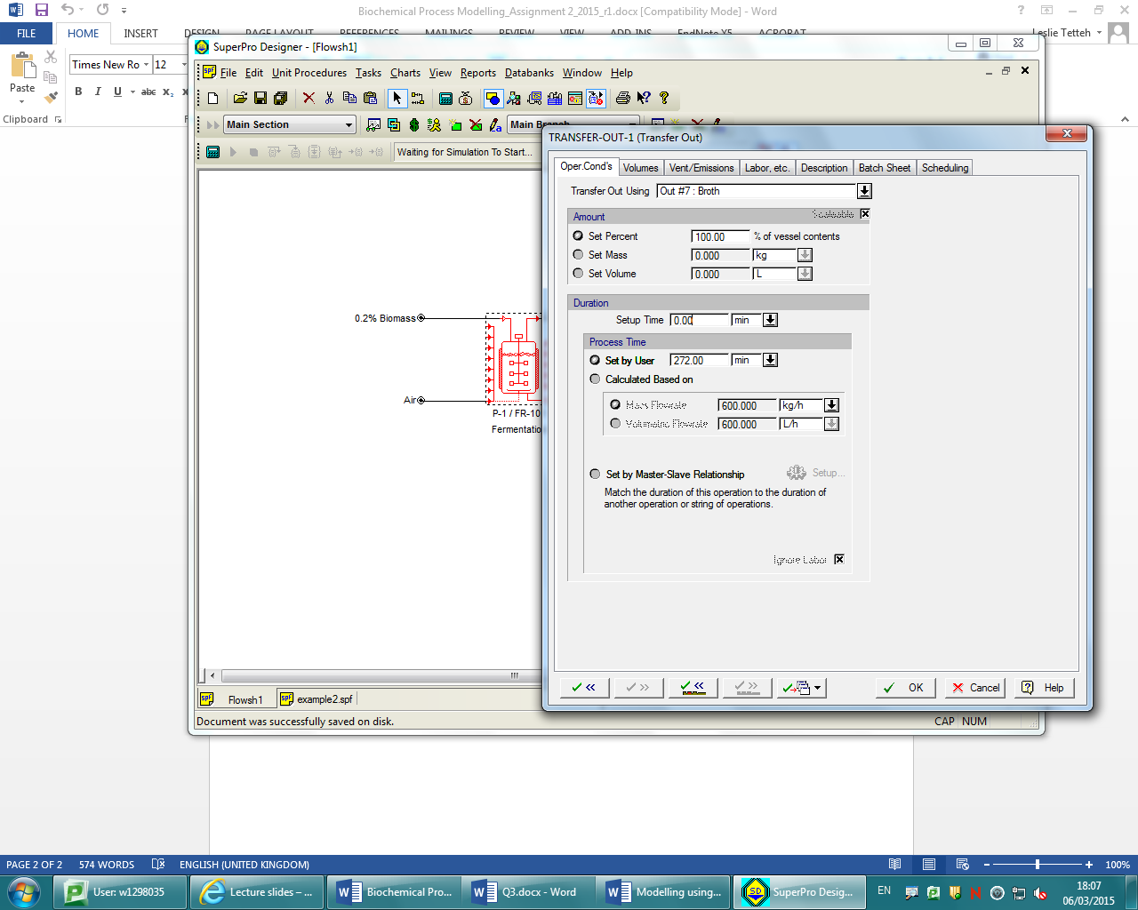

Mass and energy balances were then performed on all streams, where it was found that the amount of biomass was 23.9243 kg

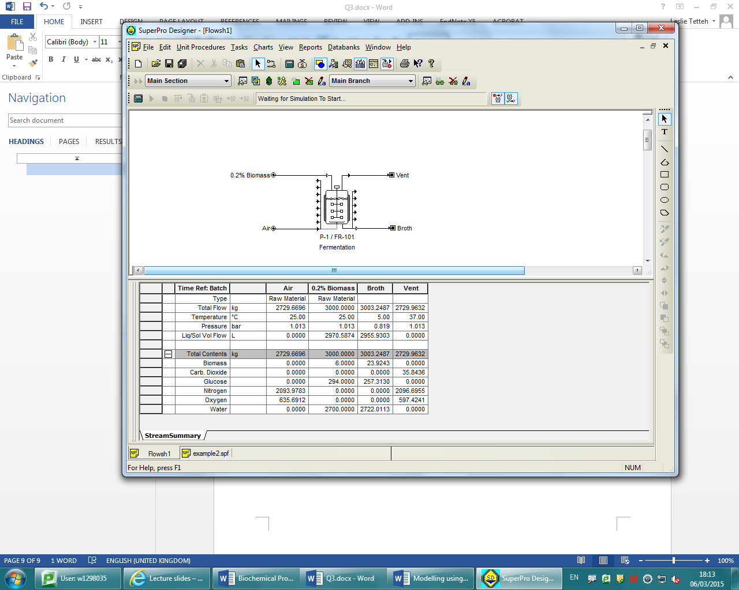

Air flow was then changed to 1.0 vvm

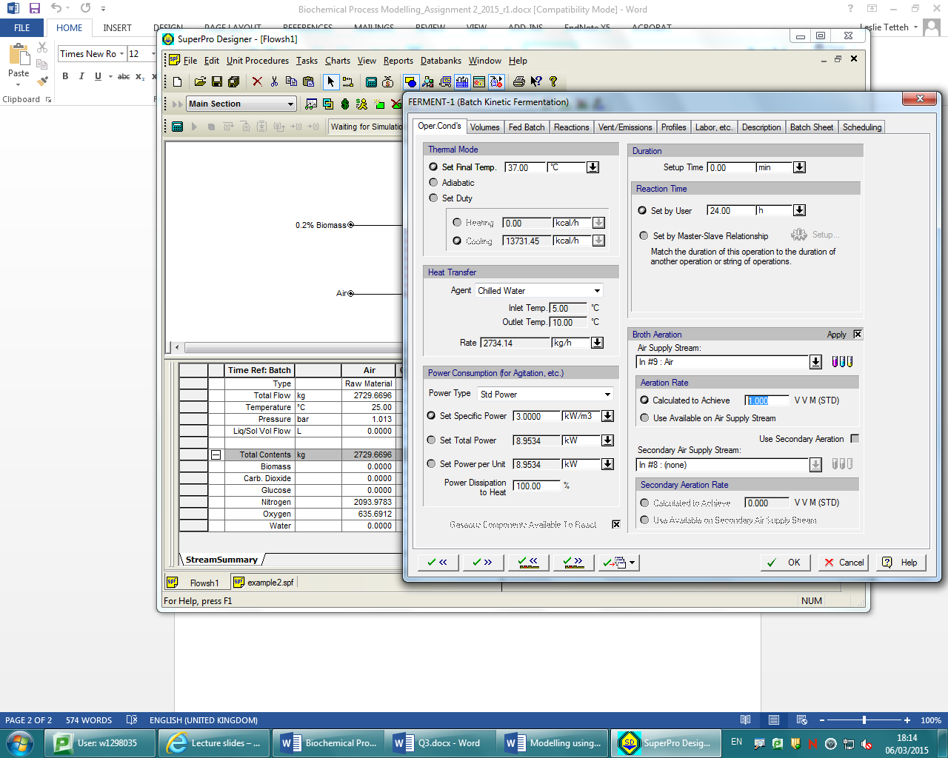

This produced the same output for the amount of biomasss, however there was more gaseous material vented.

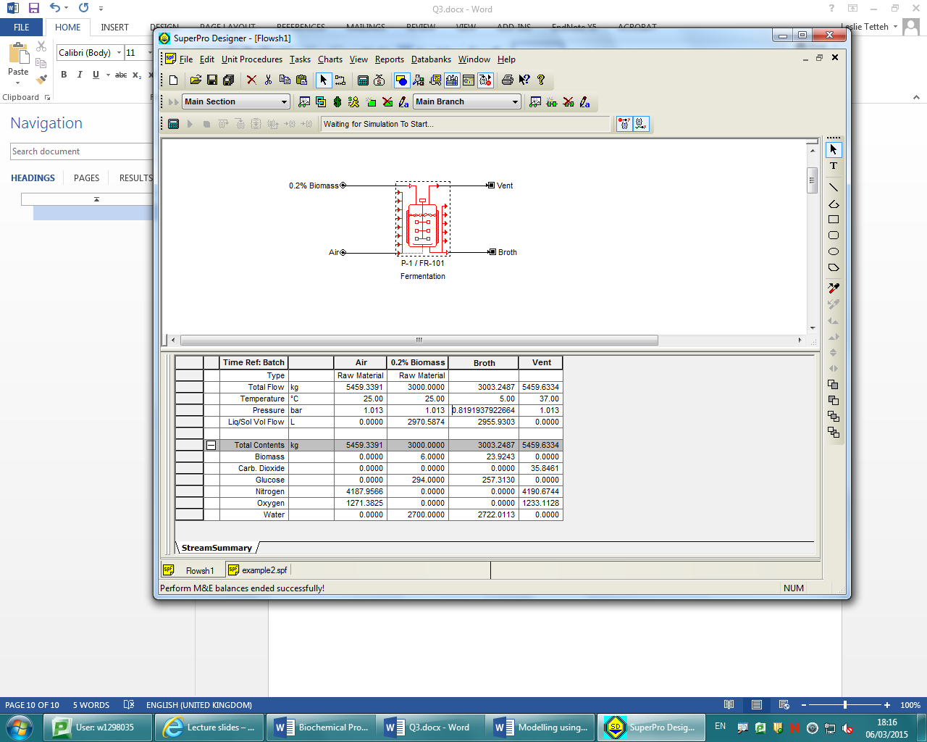

Question 3b

Components of the biomass input stream were changed to 0.2% biomass, 15% Glucose and 84.8% water

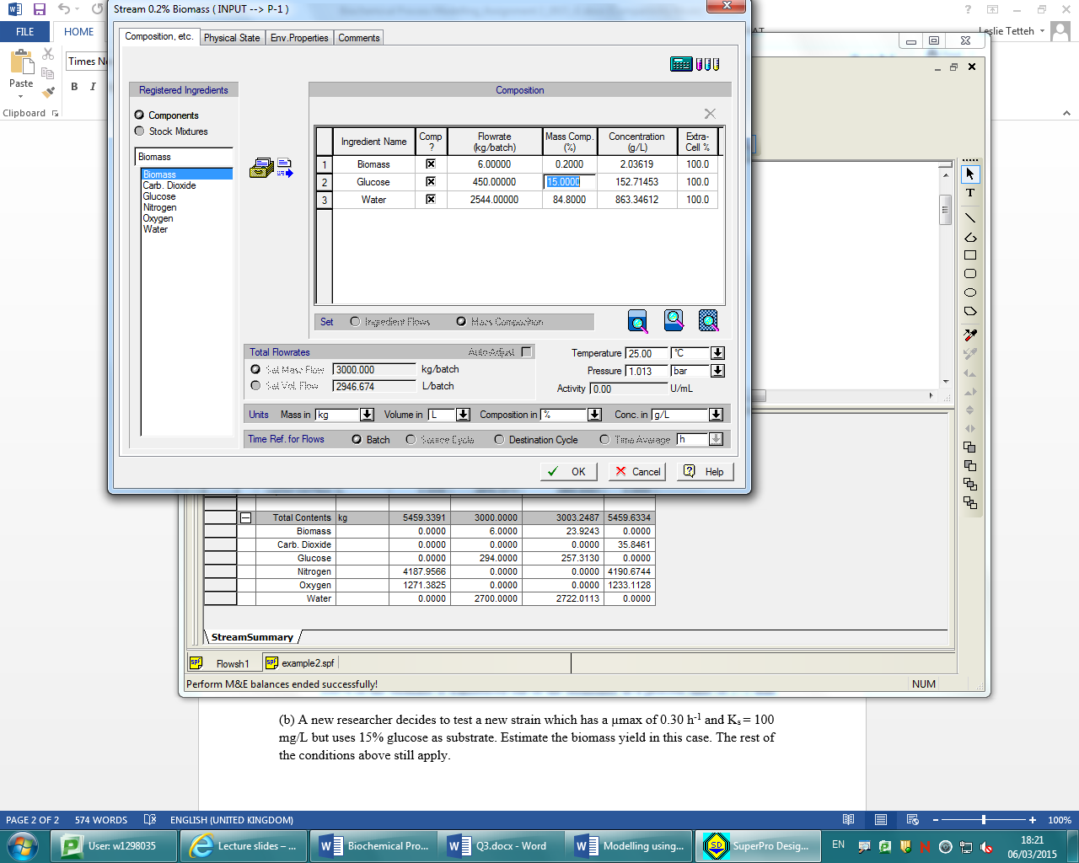

Monod’s constant was also changed to 100 mg/L whilst the μmax value was changed to 0.3h-1

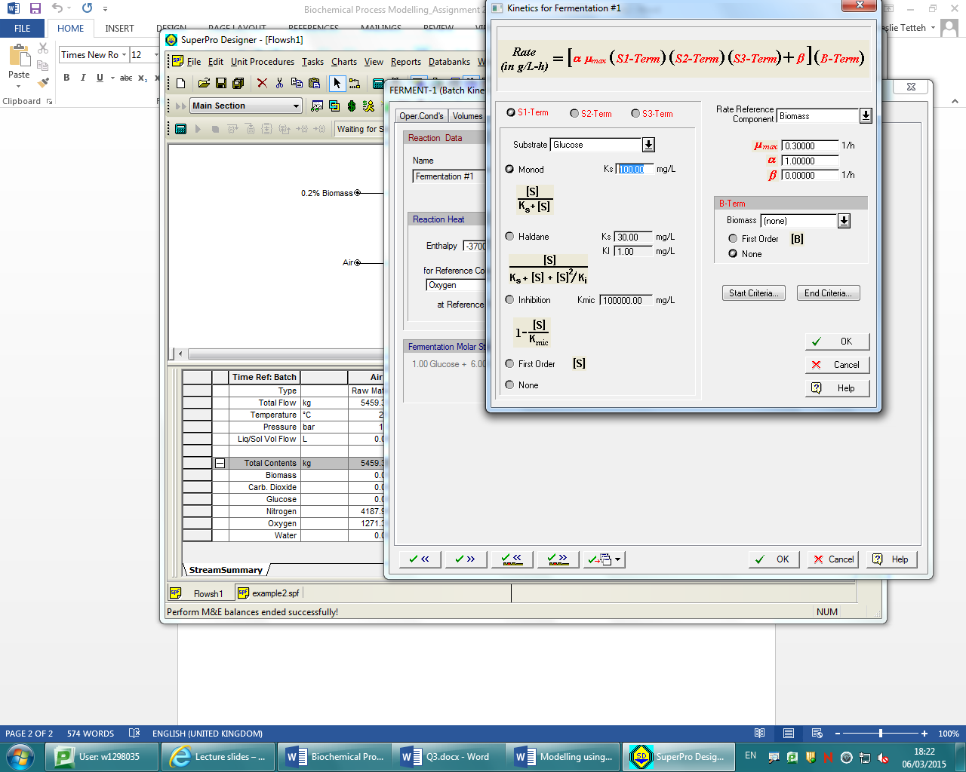

New mass and energy balances were calculated where the contents of the product stream were now found to contain 27.3367kg of biomass.

